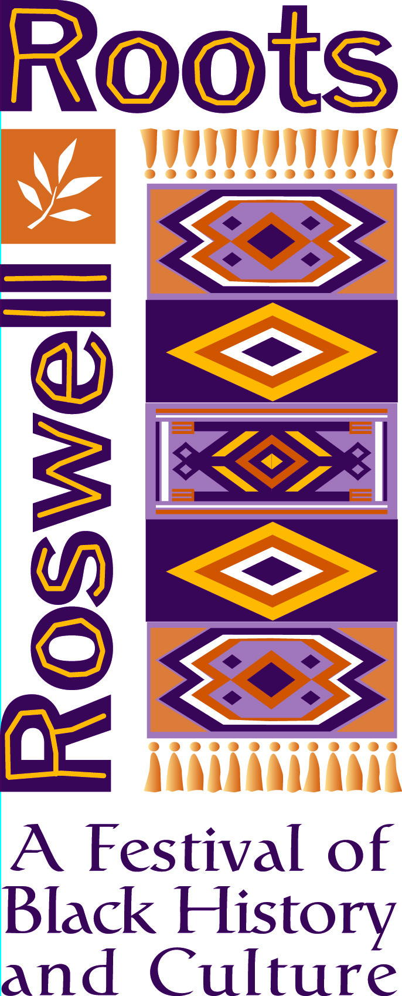

“Roswell Black History Month”

Whereas, The celebration of Black History Month was begun by Dr. Carter G. Woodson, the son of former slaves and Black History Month has been celebrated nationally in America since 1926; and

Whereas, The Historic and Cultural Affairs Division of the City of Roswell Recreation, Parks, Historic and Cultural Affairs Department working with a volunteer Steering Committee established the "Roswell Roots: Festival of Black History and Culture" in 2002; and

WHEREAS, The Groveway Community Group, the Roswell Regional Library, the North Fulton Child Development Center, the Roswell Visitors’ Center and First Baptist Church of Roswell are also sponsoring events; and

Whereas, The Hammonds House Museum, Kennesaw State University, Red Door Playhouse, The Georgia Poetry Society, Pleasant Hill Missionary Baptist Church and The Teaching Museum North are partnering with the City in support of various events and exhibits; and

Whereas, The 2010 Roswell Roots Festival includes a total of five exhibits and 12 special events including a Step Dance Competition, a Poetry Slam, storytelling, the Unity concert, tea and hat fashion shows, and more.

NOW THEREFORE, I, Jere Wood, Mayor of the City of Roswell, do hereby
proclaim all of February 2010 as Black History Month and call upon all our citizens to
recognize this special celebration of African American heritage and culture through
participation in all of the events of the Roswell Roots Festival.

In witness whereof, I have hereunto set my hand and caused the seal of the city of Roswell to be affixed
this 1st day of February, 2010.

Jere Wood, Mayor

