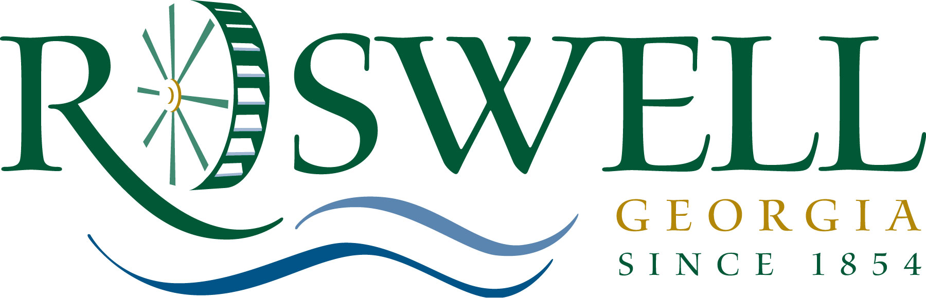

M E M O R A N D U M

TO: Community Development and Transportation Committee

FROM: Stefanie Dye, Community Development Program Coordinator

DATE: June 29, 2011

SUBJECT: Resolution to Accept Arts Village Infrastructure II CDBG Grant

The 2011 Arts Village Infrastructure II project is the demolition of the apartment building at 15 Oxbo Rd. that was acquired with CDBG funding in 2010. The Mayor and City Council approved a resolution to submit the Arts Village Infrastructure II CDBG grant to Fulton County on February 14, 2011. The amount of funds that will go towards the project is $156,247.43. The expected completion of the infrastructure is December 31, 2011.

Committee Action:
Staff requests that the committee approve placing this item on the July 11, 2011 Mayor and City Council meeting agenda.

