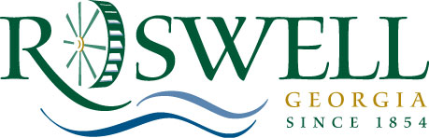

MEMORANDUM

Date: July 27, 2011

To: Community Development and Transportation Committee

From: Alice Wakefield, Community Development Director

Subject: Special Event – City Sponsorship and Road Closure

The American Legion, Veterans of Foreign Wars, and Roswell Rotary Club are commemorating the 10th anniversary of 9/11 on Sunday, September 11, 2011. The event consists of ceremonial laying of wreaths from 8:30am to 10:30am at the Faces of War Memorial, a Remembrance Walk from City Hall to the Warrior Service Center at 140 Dobbs Drive, Roswell GA, and a reception at the Warrior Service Center until 5pm.

They are requesting City sponsorship for use of the Faces of War Memorial, police escort for the Remembrance Walk, and miscellaneous services as needed. The estimated cost of this event is $1021.00.

They are also requesting closure of one lane on Oak Street east of Ellis Street due to lack of paved sidewalk along that stretch. See attached map.

