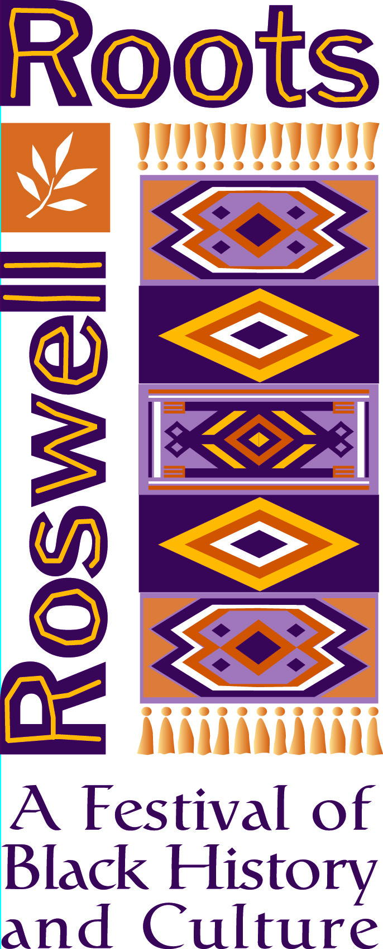

“Roswell Black History Month”

Whereas, The celebration of Black History Month was begun by Dr. Carter G. Woodson, the son of former slaves; and

Whereas, Black History Month has been celebrated nationally in America since 1926; and

Whereas, February was designated Black History Month in recognition of Black achievements that greatly impacted American history; and

Whereas, The Historic and Cultural Affairs Division of the City of Roswell Recreation, Parks, Historic and Cultural Affairs Department working with a volunteer Steering Committee will host the "Roswell Roots: Festival of Black History and Culture" for the 11th year; and

WHEREAS, The Groveway Community Group, the Roswell Regional Library, Barrington Hall, Bulloch Hall, Smith Plantation, The Teaching Museum, the Visitors’ Center, Zion Missionary Baptist and Pleasant Hill Community Center are also sponsoring events; and

Whereas, The 2012 Roswell Roots Festival includes five exhibits and 15 events such children’s’ theater, storytelling, lectures, the Unity concert, the poetry slam, a cornbread cook-off, the tea and hat fashion show, and more;

Whereas, The Roswell Roots Festival celebrates the contributions of Roswell's African American citizens, both past and present.

NOW THEREFORE, I, Jere Wood, Mayor of the City of Roswell, do hereby
proclaim all of February 2012 as Black History Month and call upon all our citizens to
recognize this special celebration of African American heritage and culture through
participation in all of the events of the Roswell Roots Festival.

In witness whereof, I have hereunto set my hand and caused the seal of the city of Roswell to be affixed
this 23rd day of January, 2012.

Jere Wood, Mayor

