Comparison of Stormwater Construction Project Oversight
Outsourcing versus Hiring a City Employee

The purpose of this classification is to supervise, inspect and manage the Capital Improvement Projects for the Stormwater Division, which involves technical inspections of project work sites to determine compliance with all City, County, State and Federal codes and regulations regarding erosion and sediment control, clearing, drainage, landscaping, infrastructure, wetlands, and stream buffers. Incumbent performs work under the general supervision of the Stormwater Coordinator.
Outsourced
The City standby services contractor Integrated Science and Engineering (ISE) gave City Stormwater management staff a cost estimate on June 21, 2011 of $85,936 for a six-month period. This is $171,872 annually. This is for a non-engineering-degreed person who would perform construction oversight activities for the city under the supervision of the Stormwater Coordinator.
City Employee
The City of Roswell Budget staff has provided the following information for the Full Time Equivalent (FTE) position/pay grade of Stormwater Construction Specialist. This amount includes all benefits plus salary.

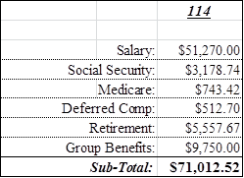

2/17/12

