LCI Five-Year Plan Update
Roswell -- Atlanta Street/Town Square LCI

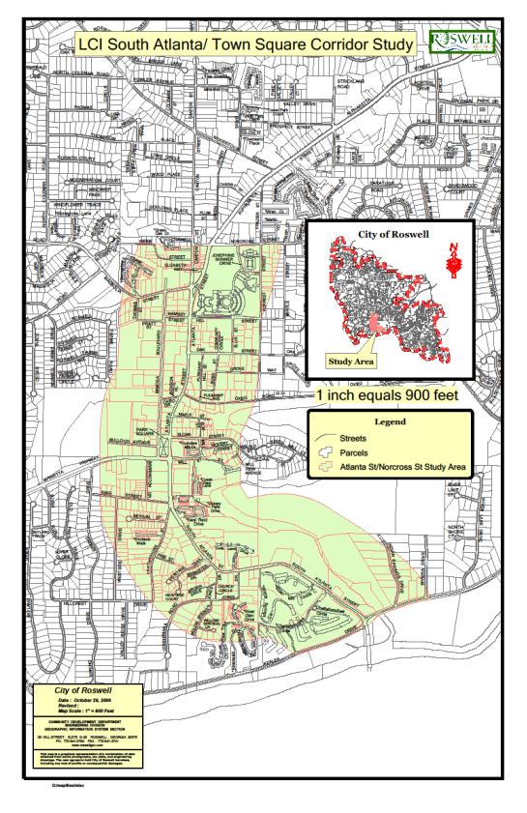

July 12, 2012

Evaluation and Appraisal Report

It is the City’s goal to address longstanding traffic issues on Atlanta Street, which is a major thoroughfare between Atlanta and the northern suburbs. To accomplish this goal while protecting and enhancing the historic Town Square area as a welcoming place for residents and visitors is a daunting task.

Roswell Town Square
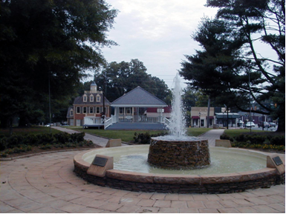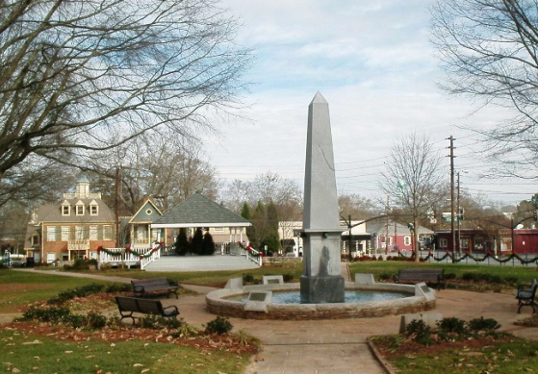
2006 2009

Plan Progress to Date
The good news is that much of the original work plan has been planned and designed, is in progress, or has been completed as seen on the list of accomplishments.

Completed Actions
- Oak Street Streetscape – Phase one of the three-phase project is now complete. The project used a combination of City and CDBG funds totaling over $1.4 million.
Oak Street
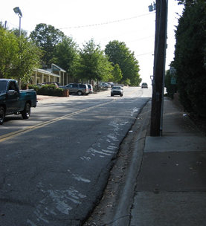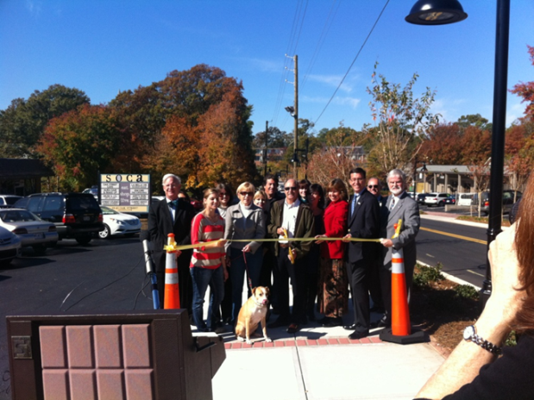
2005 2011

- Bus shelters and Simme-seats have been installed at various locations along the corridor.
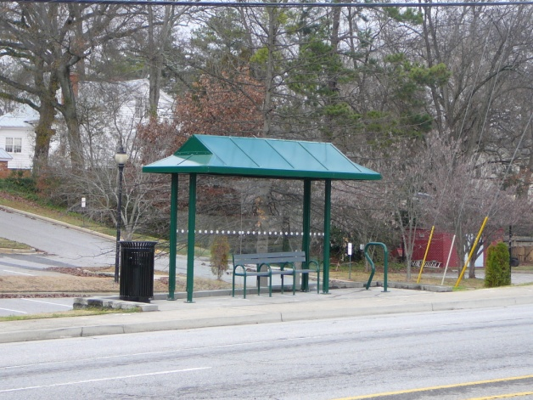
Bus Shelter on Atlanta Street at Oak Street

- Town Square pedestrian improvements are complete.

- Barrington Hall staircase – a staircase was constructed in the Northeast corner from the traffic signal at the intersection of SR 9 and 120 leading up to Barrington Hall as was recommended by the Town Square Charrette and later by the Atlanta St LCI Study.

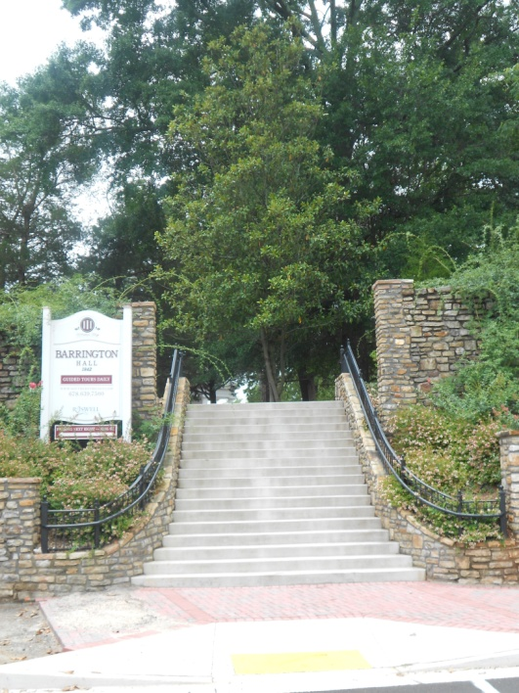
Barrington Hall Staircase

- Wayfinding signage was installed throughout the historic district. This project was funded with a Preserve America grant and City funding. Three pedestrian kiosks were installed in the LCI area as part of this project.
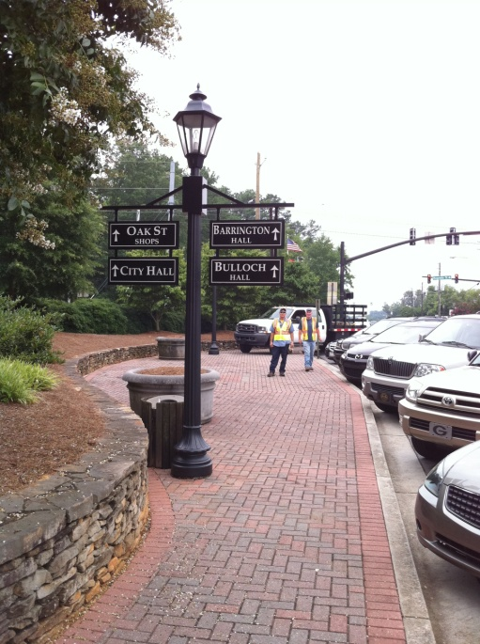
Vehicular Directional Sign

- A hybrid form-based code was developed for the Groveway neighborhood to guide redevelopment in that area.

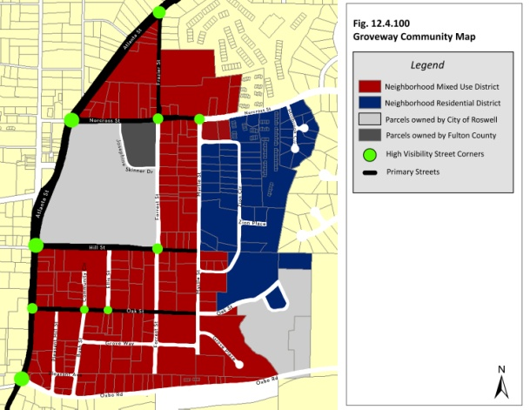
Groveway Community

- An historic district overlay was developed in response to a proposed mixed-use project that was slated to be built on property bordering the square. The project and overlay were approved though the project was tabled because of finances.

- The City reactivated its Downtown Development Authority and has funded the entity and provided training and staffing.

- City’s Transportation Master Plan was updated and adopted to include several items in the Atlanta Street LCI Action Plan such as access management, connectivity, pedestrian policies, and bicycle policies.

- The City adopted a Complete Streets policy by resolution of the Mayor and City Council.

New Development
- No new development has been completed in this built-out area of Roswell. Some redevelopment projects have been slated, but abandoned due to the tightened lending environment. Some adaptive reuses have also occurred, but none that are transformative.

Infrastructure Improvements
- New, larger waterline that will be able to accommodate multi-story development along the corridor.
- City is undergoing siting for a new water storage facility in the vicinity of the Groveway neighborhood in the LCI area.
- The Oak Street Streetscape project included underground utility relocation for all utilities other than power, which was relocated on taller poles out of the sidewalk.

In Design
- Historic Gateway Transportation Project and Master Plan: Many of the issues and concepts proposed in the Atlanta Street LCI study have been grouped together to be engineered as one project: the Historic Gateway Transportation project. The two main components of this project are removing the reversible lanes on SR 9 from the Chattahoochee River to south of the square, and improving the intersection of SR 9, Riverside Dr., and Azalea Dr. at the Chattahoochee River. Several connectivity concepts have been incorporated into this project including the Allenbrook Road network, and the multi-use path on Atlanta St. Replacement of the Riverside Rd. Bridge is also part of this project.

Historic Gateway Master Plan Area

Historic Gateway Transportation Project Alternative

- Tax Allocation Districts have been authorized through the passage of the Redevelopment Powers referendum. Interest in targeting areas is starting to pick up as many believe we are currently seeing the bottom of the market.

Not Accomplished – barriers, no longer relevant
- Riverview area: Study of potential overlay to allow condos and limited restaurant use. This is no longer being considered. Further study through the Strategic Economic Development Plan and the Historic Gateway Master Plan do not support the viability, and other options are preferred.

- Homeowner assistance for City Employees: Was rejected during the Comprehensive Plan process.
- Transportation Management Association: Was determined to be a CID function, not appropriate for City government.

- Pedestrian Access to Vickery Park: Feasibility of constructing a hardscape stairway from Atlanta Street to the mill and covered bridge. It was determined that this would take place through private property development.

Implementation Plan and Updated Five-Year Action Plan

Project implementation is a primarily group effort of elected officials, City staff in multiple departments, and the Georgia Department of Transportation. The Roswell Mayor and City Council are ultimately responsible for programming how projects are implemented through the annual budget process, the annual Short Term Work Plan update, Capital Improvements Element/Plan, the Transportation Master Plan, and prioritization of the Transportation Improvement Plan. These documents are the direction that staff uses to program improvements. Conversely, staff recommendations are utilized as a starting point for the Mayor and City Council in determining priorities.

The Atlanta Street corridor is not only a State route through Roswell, but a significant local road that abuts the City’s Historic Square, and is a major spine for other infrastructure such as water and sewer lines. Implementation happens in various departments depending on the nature of the action item, and which department has responsibility for each item. Interdepartmental coordination of projects is needed to reach the best outcome. For instance, the staffs of the Transportation Department and Community Development Department meet to discuss LCI study objectives and how they relate to current or future transportation projects. When a project impacts a City park such as the Square, Barrington Hall, Bulloch Hall, or the Vickery Creek Park, as is often the case, the Recreation, Parks, Historic and Cultural Affairs Department collaborates with the Transportation Department. When overhead or underground infrastructure is impacted, the Environmental/Public Works Department is involved.

Staff also meets with stakeholders in project areas as plans and designs are being developed. This input is critical in having a successful process and project. Since the Atlanta Street corridor passes the Chattahoochee River National Recreation Area, projects are sometimes coordinated with the National Park Service. Additionally, Georgia Power is a stakeholder because of the vast utility infrastructure along the corridor. The City has also coordinated with the Roswell Housing Authority, and recently supported their application for a Low Income Housing Tax Credit project with a pledge of $777,587 for construction if the application is successful. Neighbors and businesses are also important stakeholders, and City staff meets with homeowners associations, merchant and business associations, and faith-based organizations as part of the collaboration process. Since the creation of the Roswell Business Alliance and the Downtown Development Authority early this year, collaboration should increase with the formalized structure these entities can provide. Forging these relationships will be a key strategy to ensure continued support.

The primary monitoring structure for the Atlanta Street LCI study includes the reporting and update mechanisms provided by the Atlanta Regional Commission. These conditions of LCI funding, provides the City with the incentive to monitor the plan annually, and to revise the implementation program accordingly.

5-Year Action Plan

The attached five-year action plan was developed after a review and revision of the original action plan laid out in the 2007 LCI study. Items that are underway yet not complete make up the bulk of the plan. Items from the original plan that were not initiated and are no longer relevant have been indicated as such on the chart. The Historic Gateway Transportation project rolls in several items from the LCI study. The City is currently in design and environmental review for this project with a consultant. A Master Plan for land uses in the Historic Gateway area is currently being prepared using a combination of City and LCI Supplemental Study funds. The deliverables should be finalized by the end of July 2012.

Other changes to City planning and zoning documents will impact the Atlanta Street LCI area. The City’s 2030 Comprehensive Plan was adopted in October 2011. The new plan is the first to include Character Areas under the State’s Minimum Planning Standards since their adoption. This new comprehensive plan put an end to the future land use map, which is now unnecessary. The City is currently under contract with a consultant to write a Unified Development Code (UDC), which is expected to be finished around the end of 2013 or early 2014. The focus will be on areas and categories that need to change for example adding mixed use categories, establishing different classifications of the commercial categories, changing the FC-A classification so that the properties on the map clearly show their zoning. The UDC will also change how we define items, how we deal with the signage and it will also include some changes to the subdivision regulations. Additionally, the City’s first Strategic Economic Development Plan is being presented for adoption before the end of July 2012. Because of all of these changes and with changes in decennial Census data, the City’s Urban Redevelopment Plan will soon undergo revision as well.

