STATE OF GEORGIA

COUNTY OF FULTON June 27, 2011

A RESOLUTION TO SET A HEARING DATE FOR AN APPEAL OF THE ISSUANCE OF AN ALCOHOL LICENSE (RETAIL PACKAGE/ LIQUOR, BEER & WINE) TO R&B WINES AND SPIRITS AND BONIFACE OUTTA 1425 MARKET BOULEVARD #300 ROSWELL, GEORGIA 30076

An appeal of the issuance of an Alcoholic Beverage License (Retail Package/Liquor, Beer & Wine) to R&B Wines & Spirits and Boniface Outta having been filed by Edwin Gabriel Whatley, owner of J’s Beverage Depot 1570 Holcomb Bridge Road Suite 610 Roswell, Georgia, the Roswell Mayor and City Council hereby adopt the following resolution:

1.

The appeal of the decision of the Roswell Alcoholic Beverage Licensing Board to issue an Alcoholic Beverage License (Retail Package/ Liquor, Beer & Wine) to R&B Wines and Spirits and Boniface Outta shall be heard before the Roswell Mayor and City Council at the regularly scheduled meeting of Mayor and City Council on July 25th 2011 at 7:00 P.M. in Council Chambers at Roswell City Hall, 38 Hill Street Roswell, Georgia 30075.

2.
The appeal shall be based on those specific items listed in the written appeal contained herein as Exhibit “A” and no other matters.

Let this Resolution be provided to the Applicant as notice of said appeal along with other necessary parties.

Approved by the Mayor and City Council on this 27th day of June, 2011.

Attest: Jere Wood, Mayor

Marlee Press, City Clerk
(Seal)

______________________________ _____________________________
Councilmember Jerry Orlans Councilmember Rebecca Wynn

______________________________ _____________________________
Councilmember Betty Price Councilmember Richard Dippolito

______________________________ _____________________________
Councilmember Kent Igleheart Councilmember Nancy Diamond

Exhibit “A”
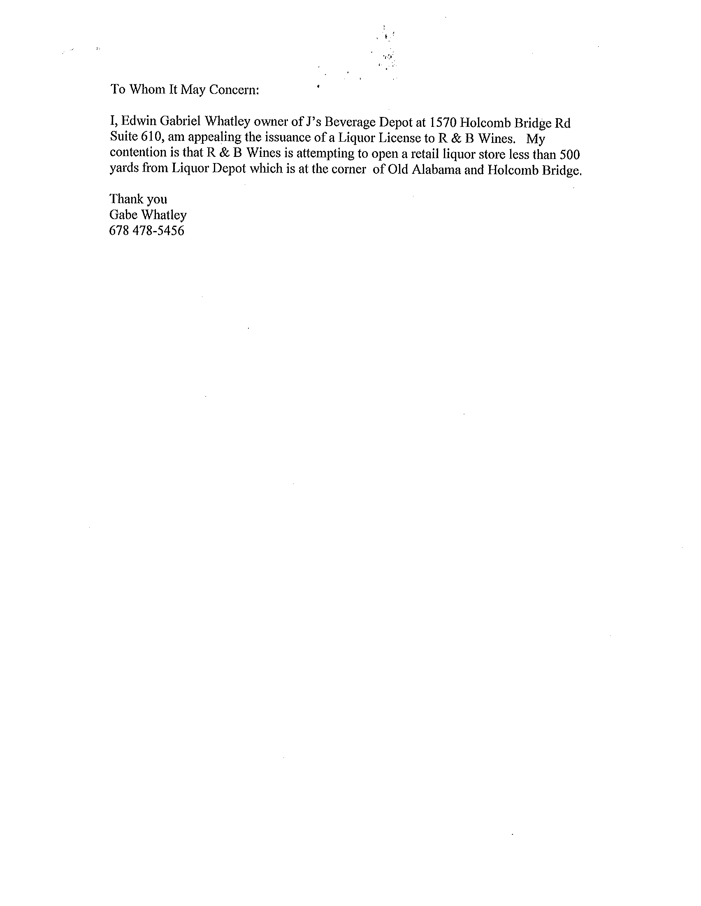
Exhibit “A”
