Rezoning Staff Report

TABLE OF CONTENTS
Page No.
I. PROJECT INFORMATION 1
II. COMMUNITY DEVELOPMENT DEPARTMENT RECOMMENDATION 2
A. RECOMMENDED STAFF CONDITIONS 2
B. RECOMMENDED PLANNING COMMISSION CONDITIONS 2
III. ASSESSMENT 2
A. SITE PLAN ANALYSIS 2
Location Map 3
Zoning Map 4
Aerial Map 5
Future Land Use Map 7
B. DESIGN GUIDELINES 8
C. LANDSCAPE PLAN ANALYSIS 8
D. TRANSPORTATION 8
E. ENGINEERING 9
F. ENVIRONMENT 9
G. FIRE 9
H. PARKS 9
I. FISCAL IMPACT 9
J. ARCHEOLOGICAL 9
K. TRAFFIC STUDY 9
IV. HISTORY 9
V. CHRONOLOGICAL LISTING OF PLANS SUBMITTED 10
VI. STANDARDS OF REVIEW 10

I. PROJECT INFORMATION

Petition Number RZ09-14

Project Name 2745 Holcomb Bridge Road Medical Office

Property Location 2745 Holcomb Bridge Road
Land Lot 781

Property Size .986 acres

Existing Zoning FC-A (Fulton County Annexed)

Proposed Zoning O-P (Office-Professional)

Owner/Petitioner Jill Fagalde

Action Requested Rezone subject property from Fulton County Annexed to Office-Professional in order to construct a 4500sf medical office.

II. COMMUNITY DEVELOPMENT DEPARTMENT RECOMMENDATION

RZ09-14 – Denial

Reasons for denial: 1. Inconsistent with Comprehensive Plan
2. Additional office space

A. RECOMMENDED STAFF CONDITIONS

The staff recommends denial of this rezoning request. Should the Mayor and City Council approve this rezoning, it shall be approved subject to the owner’s agreement to the following conditions or as may be amended by the Mayor and City Council.

- The owner/developer shall develop the property in substantial accordance with the site plan prepared by Pyramid Engineering & Development Co., LLC, stamped “Received October 9, 2009 City of Roswell Community Development Department,” and as approved by the Design Review Board and consistent with these recommended conditions.
- The owner/developer shall upgrade the pedestrian crossing signals to the latest MUTCD standards (i.e. countdown, etc.)
- The owner/developer shall upgrade the existing traffic signal to accommodate the new driveway for the proposed medical offices.
- The owner/developer shall remove the existing gravel parking pad located on southern portion of property and landscape.
- The owner/developer shall provide inter-parcel access provisions for adjacent property owners located on the east side of project site. A revised site plan shall be submitted prior to the land disturbance permit being issued.

RECOMMENDED PLANNING COMMISSION CONDITIONS

The Planning Commission recommended approval during their October 20, 2009 hearing with the following conditions.

- All of the staff conditions with amendment to #2 stating that any GDOT requirements will prevail if there are any conflicts with RDOT.

DESIGN REVIEW BOARD COMMENTS

The Design Review Board made the following comments during their October 6, 2009 meeting:
- Consider inverting the building proportions in order to minimize the damage to the two (2) large trees near the eastern boundary.

The applicant provided documentation showing the critical root zone impacted by the building does not exceed 25%.

III. ASSESSMENT

A. SITE PLAN ANALYSIS

The applicant is requesting to rezone the property from Fulton County Annexed to Office-Professional. The property is currently undeveloped and has an underlying zoning classification of AG-1 (Agricultural District). The applicant is proposing to construct a one-story, 4500 square feet medical office with 16 parking spaces. The site will be developed with an underground detention structure under the parking area. The property is surrounded by high-density residential and offices on both sides. Holcomb Bridge Middle School and a daycare center are located on the other side of Holcomb Bridge Road.

The following maps are provided: Location Map, Zoning Map, Location Aerial Map, Site Aerial Map, Future Land Use Map, and a Fulton County Zoning Map.

2745 Holcomb Bridge Road

Location Map
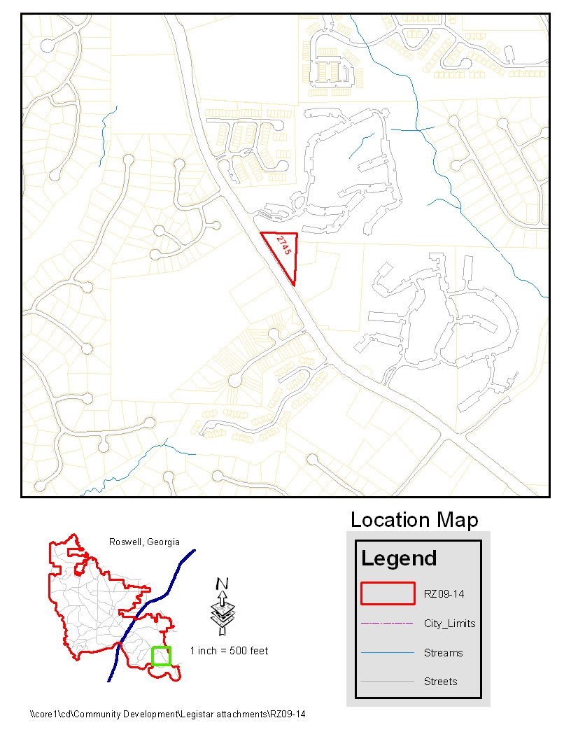

2745 Holcomb Bridge Road

Zoning Map
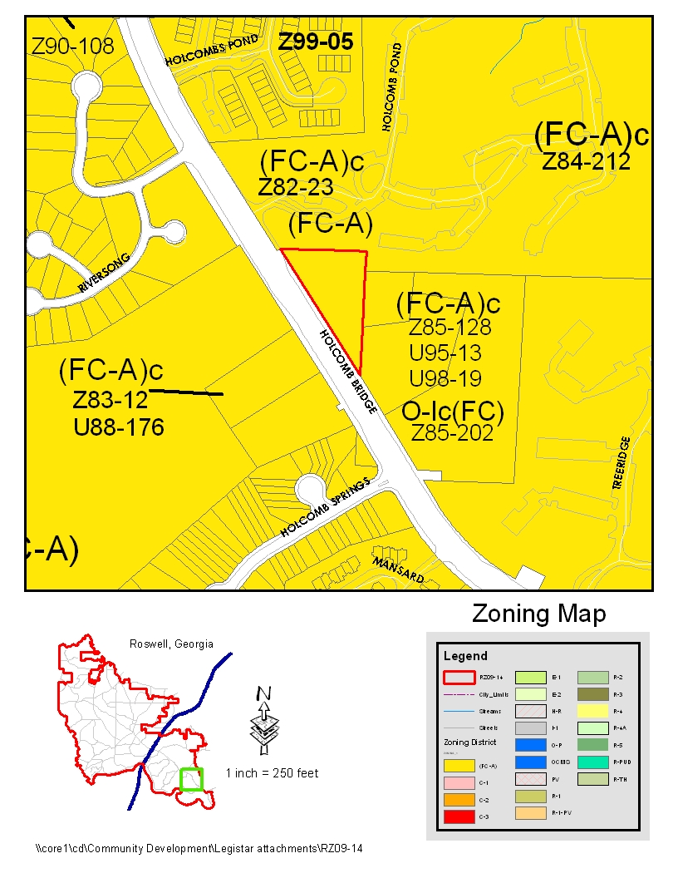

2745 Holcomb Bridge Road

Location Aerial Map

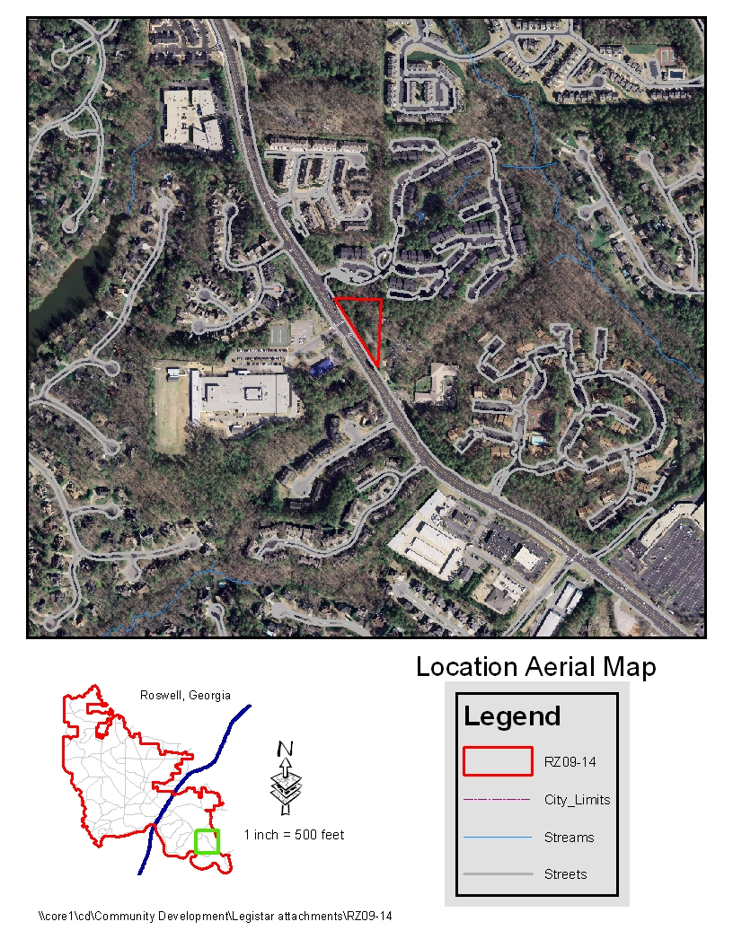

2745 Holcomb Bridge Road

Site Aerial Map

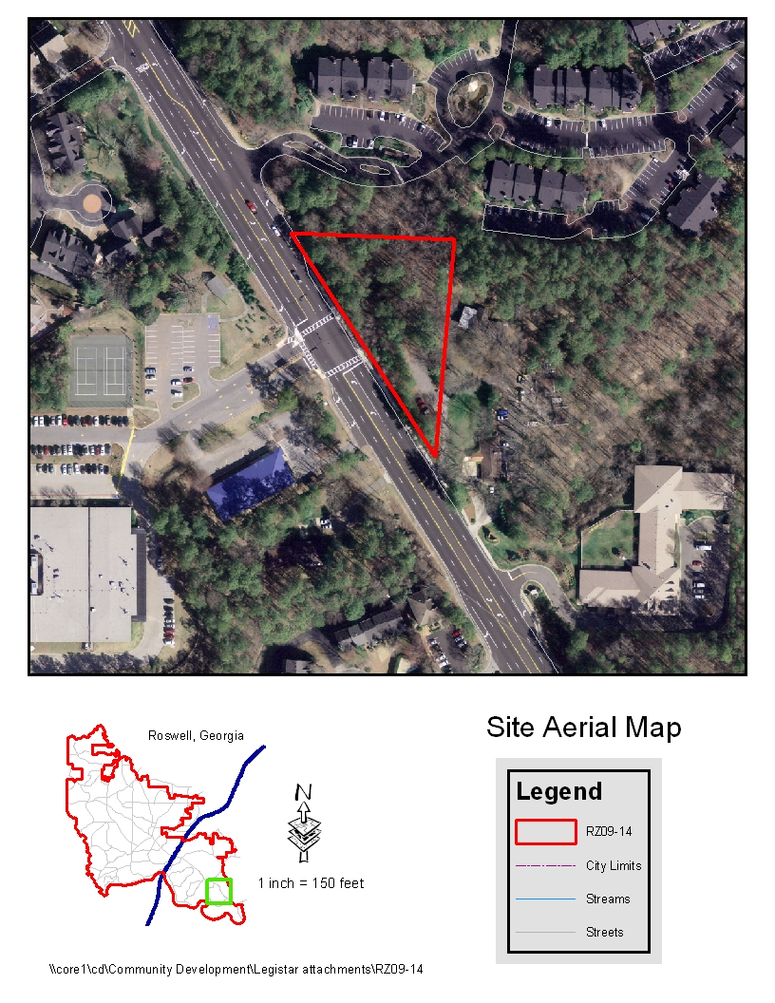

2745 Holcomb Bridge Road

Future Land Use Map

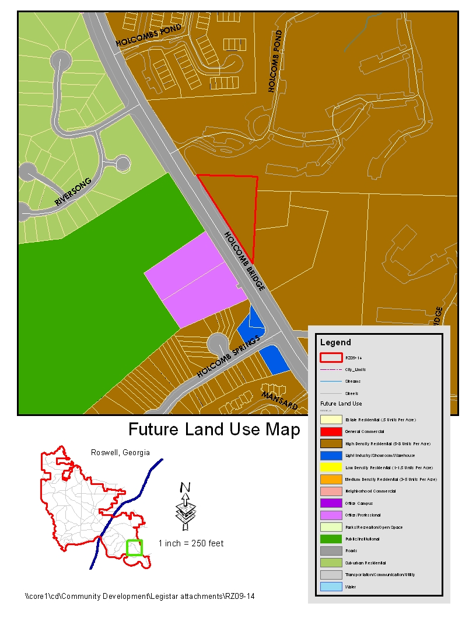

B. DESIGN GUIDELINES

The proposed medical office building is not located within any of the design districts; therefore, it falls under the Citywide Design Guidelines.

1. Shield parked vehicles from view – The plans indicate some landscaping along the front to screen the parking area. Additional landscaping can be added to help screen the parking area.

2. Shield parked surfaces from view – The plans indicate some landscaping on the property. The project will be required to be approved by the Design Review Board. Additional landscaping may be added to the site.

3. Safe Sidewalks – The proposed site plan indicates a five (5) foot sidewalk lane along Holcomb Bridge Road.

4. Treatment of large flat wall areas – The building will have to receive approval from the Design Review Board for style and architecture. Also, the board can require additional landscaping to help screen the building.

5. Softscapes – The proposed plan indicates very little landscaping on the site. The project will have to be reviewed and approved by the Design Review Board for landscaping.

6. Visual patterns on building facades – Not required for a rezoning.

7. Site lighting –All site lighting shall be in accordance with the City of Roswell lighting ordinance.

8. Contextual appearance – Not required for a rezoning.

9. Avoid visible utility lines – All utility lines shall be underground or concealed from view to the extent feasible.

C. LANDSCAPE PLAN ANALYSIS

The tree density required on the site is 30 units. The existing tree density on the site is 514.7 units. The proposed tree replacement plan indicates an additional 33 replacement units proposed on the property for a total density of 139.7 units. There are six specimen trees proposed to be removed, one 30” cherry and three 28” oaks. The remaining trees are small cherries less than 8”. The proposed tree replacement plan indicates (33) 4” trees for the recompense of the specimen trees. The proposed tree replacement plan indicates street trees along Holcomb Bridge Road and along the parking area. The plan lists Japanese Zelcovas, Tulip Poplars, Leyland Cypress, Red Sunset Maples, Southern Magnolias, and Indian Hawthorns as the proposed trees for replacement.

D. TRANSPORTATION

- Re−install all disturbed pedestrian crossing signals, ADA ramps, traffic signs, striping etc.
- Upgrade the pedestrian crossing signals to the latest MUTCD standards (i.e. countdown, etc.)
- Upgrade the existing traffic signal to accommodate the new driveway for the proposed medical offices.
- The right−of−way shall encompass all sidewalk (existing and proposed), all ADA ramps, plus a minimum one foot.

E. ENGINEERING

- Boundary survey does not include off site sanitary sewer easement; verify sewer access for proposed site.
- Existing gravel parking pad located on southern portion of property shall be removed and landscaped.
- Survey shall depict latest FEMA firm panel; survey shall include the presence or absence of any waterways within 200 feet of site
- Provide all wet and dry utility providers for project site.
- Provide interparcel access provisions for adjacent property owners located on the east side of project site.

F. ENVIRONMENT

- Areas for bio-retention and infiltration can be integrated into the site.
- Hydrodynamic device does not provide 80% TSS removal. Please set up stormwater concept meeting to discuss.

G. FIRE

- Comply with the 2000 edition of the International Fire code and appendices B, C and D.
- They must conduct a fire flow test to determine if there is adequate water available for firefighting.
- The Building construction must comply with the 2000 edition of the Life Safety Code.

H. PARKS

- No comment.

I. FISCAL IMPACT

- A fiscal impact study was done for the proposed project. According to the impact graph, the city would benefit from the fees up front and then it would be a break even proposition.

J. ARCHEOLOGICAL

- Not required

K. TRAFFIC STUDY

- Not required

IV. HISTORY (Listing of prior actions)

The subject property was annexed from Fulton County to the City of Roswell in 1999. The property was zoned Agricultural (AG-1) under Fulton County regulations which is equivalent to E-2 (Single Family Residential). The property is currently zoned FC-A (Fulton County Annexed). There are no pre-existing planning or zoning conditions on the property.

V. CHRONOLOGICAL LISTING OF PLANS SUBMITTED

Original plans submitted – September 8, 2009
Revised plans submitted – October 9, 2009
Critical root zone analysis of two (2) damaged trees – October 9, 2009

VI. STANDARDS OF REVIEW

- Whether or not the proposal will permit a use that is suitable in view of the use and development of adjacent and nearby property? (O.C.G.A. § 36-67-3(1))

Adjacent properties are presently high density multi-family housing and office uses. The proposed use would be consistent to those uses.

- Whether or not the proposal will adversely affect the existing use or usability of adjacent or nearby property (O.C.G.A. 36-67-3(2))

The proposed use is similar to those presently existing on adjacent parcels. This should pose no adverse effects on the existing adjacent properties.

- Whether the property to be affected by the proposal has a reasonable economic use as currently zoned (O.C.G.A. 36-67-3(3)).

The property is presently zoned FC-A, with no economic viability as a single family residence or agricultural use on Holcomb Bridge Road.

- Whether the proposal will result in a use which will or could cause an excessive or burdensome use of existing streets, transportation facilities, utilities or schools (O.C.G.A. 36-67-3(4))

The request will not result in a use that would be burdensome to the existing streets, transportation facilities, utilities, or schools.

- Whether the proposal is in conformity with the policy and intent of the Comprehensive Plan including the land use element (O.C.G.A. 36-67-3(5))

The comprehensive plan indicates that the property shall be high density residential. The proposed use is not in conformity with the 2025 Comprehensive Plan.

- Whether there are other existing or changed conditions affecting the use and development of the property which gives supporting grounds for either approval or disapproval of the proposal (O.C.G.A. 36-67-3(6))

There are no existing conditions that affect this proposal.

- Existing use(s) and zoning of subject property

The property is presently zoned FC-A (Fulton County Annexed). The property was annexed into the City of Roswell when it was previously zoned AG-1 (Agricultural) under Fulton County jurisdiction. The property retained all the rights and privileges of this zoning classification.

- Existing uses and zoning of nearby property.

Location in relation to subject property | Zoning | Land Use | Acreage | Density
North | FC-A | Apartments | 30 acres | 10 upa
South | N/A | N/A | N/A | N/A
East | FC-A | Office | .561 acres and 1.69 acres | 1,540 SF and 1124 SF per acre
West | FC-A | Road, Public School, and  Daycare Center | 1.16 acres (daycare) | 7,060 SF per acre

- An explanation of the existing value of the property under the existing zoning and/or overlay district classification.

The application does not indicate what the existing value of the subject property is under the FC-A zoning classifications.

- Whether the property can be used in accordance with the existing regulations.

The current regulations restrict the property to agricultural uses and a single family dwelling.

- The extent to which the property value of the subject property is diminished by the existing zoning district and/or overlay district classification.

An appraisal of the property would have to be completed to determine whether the subject property is diminished due to the existing zoning classifications.

- The value of the property under the proposed zoning district and/or overlay district classification.

An appraisal of the property would have to be completed to determine the value of the subject property under the proposed O-P (Office Professional) district classification.

- Suitability of the subject property under the existing zoning district and/or overlay district classification for the proposed use.

The property is presently zoned FC-A, with an underlying AG-1 zoning classification, which does not permit offices as an approved use.

- The suitability of the subject property under the proposed zoning district and/or overlay district classification.

The proposed office development would be a suitable use under the O-P (Office-Professional) zoning district.

- The length of time the property has been vacant or unused as currently zoned.

The property has been vacant and undeveloped for an unspecified period of time.

- A description of all efforts taken by the property owner(s) to use the property or sell the property under the existing zoning district and/or overlay district.

The application submitted by the applicant does not indicate what efforts may have been taken by the property owner to sell or use the property under the existing zoning.

- The possible creation of an isolated zoning district unrelated to adjacent and nearby districts.

The proposed O-P (Office-Professional) zoning will not create an isolated district, due to similar office establishments in the area.

- Possible effects of a change in zoning or overlay district map, or change in use, on the character of a zoning district or overlay district.

With institutional and other office uses adjacent to the site, the proposed office development may be similar in character to most of the surrounding uses; however, it is not consistent with the 2025 Comprehensive Plan.

- Whether the proposed zoning map amendment or conditional use approval will be a deterrent to the value or improvement of development of adjacent property in accordance with existing regulations.

Based on the information provided by the applicant, there is no indication of a deterrence to the value of adjacent property.

- The possible impact on the environment, including but not limited to, drainage, soil erosion and sedimentation, flooding, air quality and water quality.
The site is relatively flat with a 16’ change in grade from the high point to the low. There are no streams on the property. The underground detention drains to the north toward the apartments which eventually flows toward the unnamed perennial stream that makes the northeastern boundary of the property.

- The relation that the proposed map amendment or conditional use bears to the purpose of the overall zoning scheme, with due consideration given to whether or not the proposed change will carry out the purposes of these zoning regulations

Although the property is zoned FC-A with an underlying zoning of AG-1, the site will not be developed for a single family dwelling. The 2025 Comprehensive Plan shows the area as high density residential.

- The consideration of the preservation of the integrity of residential neighborhoods shall be considered to carry great weight. In those instances in which property fronts on a major thoroughfare and also adjoins an established residential neighborhood, the factor of preservation of the residential area shall be considered to carry great weight.

The subject property is adjacent to an apartment complex that is setback at least 80’ from the property line. The closet apartment building is over 300’ from Holcomb Bridge Road and separated from the proposed development by a parking area. The site plan for the proposed development shows a 40’ transition buffer between the property line and parking area along the northern border. The proposed office building will be located 93’ from the property line.

- The amount of undeveloped land in the general area affected which has the same zoning or overlay district classification as the map change requested.

None

Appendix Attachments:

- Application
- Letter of intent
- Site/survey plan
- Tree plan
- Critical root zone analysis of damaged trees

RZ/Staff Reports/2009/RZ09-14

