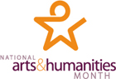

ROSWELL ARTS AND HUMANITIES MONTH
WHEREAS, The month of October has been recognized as National Arts and Humanities Month by thousands of arts and cultural organizations, communities, and states across the country, as well as by the White House and Congress for more than two decades; and
WHEREAS, The arts and humanities embody much of the accumulated wisdom, intellect, and imagination of humankind; and
WHEREAS, The arts and humanities enhance and enrich the lives of every American; and

WHEREAS, The arts and humanities play a unique role in the lives of our families, our communities, and our country; and
WHEREAS, The nonprofit arts industry also strengthens our economy by generating $135.2 billion in total economic activity annually and by supporting the full-time equivalent of 4.13 million jobs; and
WHEREAS, The twenty five arts and cultural organizations of Roswell also contribute significantly to our community’s quality of life and should be acknowledged and recognized for all their contributions.

NOW THEREFORE, I, Jere Wood, Mayor of the City of Roswell, do hereby proclaim
October 2012 as Roswell Arts and Humanities Month and call upon all our citizens to celebrate and promote the arts and culture in our community by recognizing this special celebration and through participation in the cultural events offered throughout the City.

In witness whereof, I have hereunto set my hand and caused the seal of the city of Roswell to be affixed this 8th day of October, 2012.

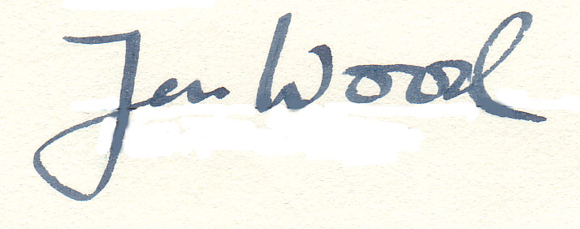
_____________________________________________
JERE WOOD, MAYOR

