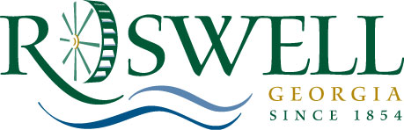

MEMORANDUM

TO: Community Development / Transportation Committee

FROM: Alice Wakefield,
Director of Community Development

DATE: March 30, 2011

SUBJECT: Creating and Appointing the Strategic Economic Development Plan Steering Committee - Guidance

On January 31, 2011, City Council Mayor and City Council approved the selection of RKG Associates, Inc., for award of contract for the Strategic Economic Development Plan (SEDP.) It is important that the plan include extensive stakeholder and community participation. One of the most effective tools used to enhance public participation is through the creation of an ad hoc advisory committee known as a steering committee.

Therefore, Staff is asking the Mayor and City Council to create and appoint members to the Strategic Economic Development Plan (SEDP) Steering Committee. The SEDP Steering Committee is critical to the process since they will act as liaisons to diverse segments of the community in order to communicate various aspects of the process, elicit feedback, and help identify people and resources to assist in the development of the plan and ongoing implementation. The Steering Committee will serve to keep the process on track and verify key issues. The project will include a number of Steering Committee meetings, along with presentations to the Roswell City Council, beginning with a project kickoff meeting and followed by meetings sequenced around the presentation of project.

Staff recommends that the committee be approximately 14 members which will ensure enough of a quorum for meaningful discussion while representing enough stakeholder groups. It is further recommended that the committee include key members of the public and private sector. Potential committee members include leaders in the community: business leaders (large and small employers), civic leaders, educational leaders, faith-based representatives, non-profit leaders, business/development organizations, and representatives from the Roswell Housing Authority, Convention and Visitors Bureau, the Greater North Fulton Chamber, and the Blue Ribbon, Green and Redevelopment Committees. In addition, it is recommended that the Community Development Council Liaison serve as an ex-officio member.

Therefore, the Department is asking that the Committee approve the placement of a resolution creating the SEDP Steering Committee and appointing the members on the April 11, 2011 Council agenda for approval.

