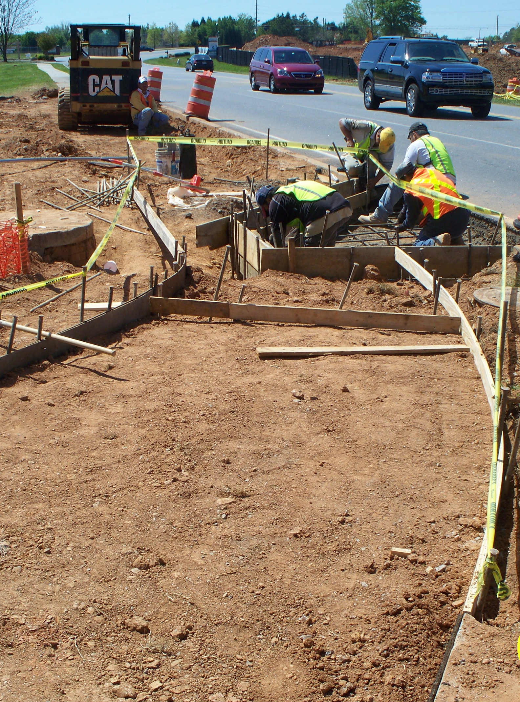
Capital Improvement Program

A five-year Capital Improvement Program (CIP) is developed and updated annually. The capital budget
is the first year of the CIP and provides the basis for control of expenditures for the acquisition of
significant City assets and construction of all capital facilities. As capital improvement projects are completed they are capitalized and the operations
and maintenance are funded in the annual operating budget.

Capital Improvement Program

The FY 2014-FY 2018 Proposed Capital Improvement Program

The FY 2014–FY 2018 Proposed Capital Improvement Program totals $115,193,743. A summary of the plan is as follows:

FY 2014 –FY 2018 CIP

General Fund New Initiative Capital:

General Fund Maintenance Capital:

FY 2014 –FY 2018 CIP

General Fund One-Time Capital:

FY 2014 General Fund Requests Funded with FY 2013 Re-Programming:

Unfunded FY 2014 General Fund Requests:

FY 2013 –FY 2017 CIP

Other Funds:

Solid Waste Fund:

Fleet Services Fund:

Water Fund:

Stormwater Utility Fund:

FY 2014 –FY 2018 CIP

Confiscated Assets Fund:

E-911 Fund:

Recreation Participation Fund:

Impact Fee Fund:

