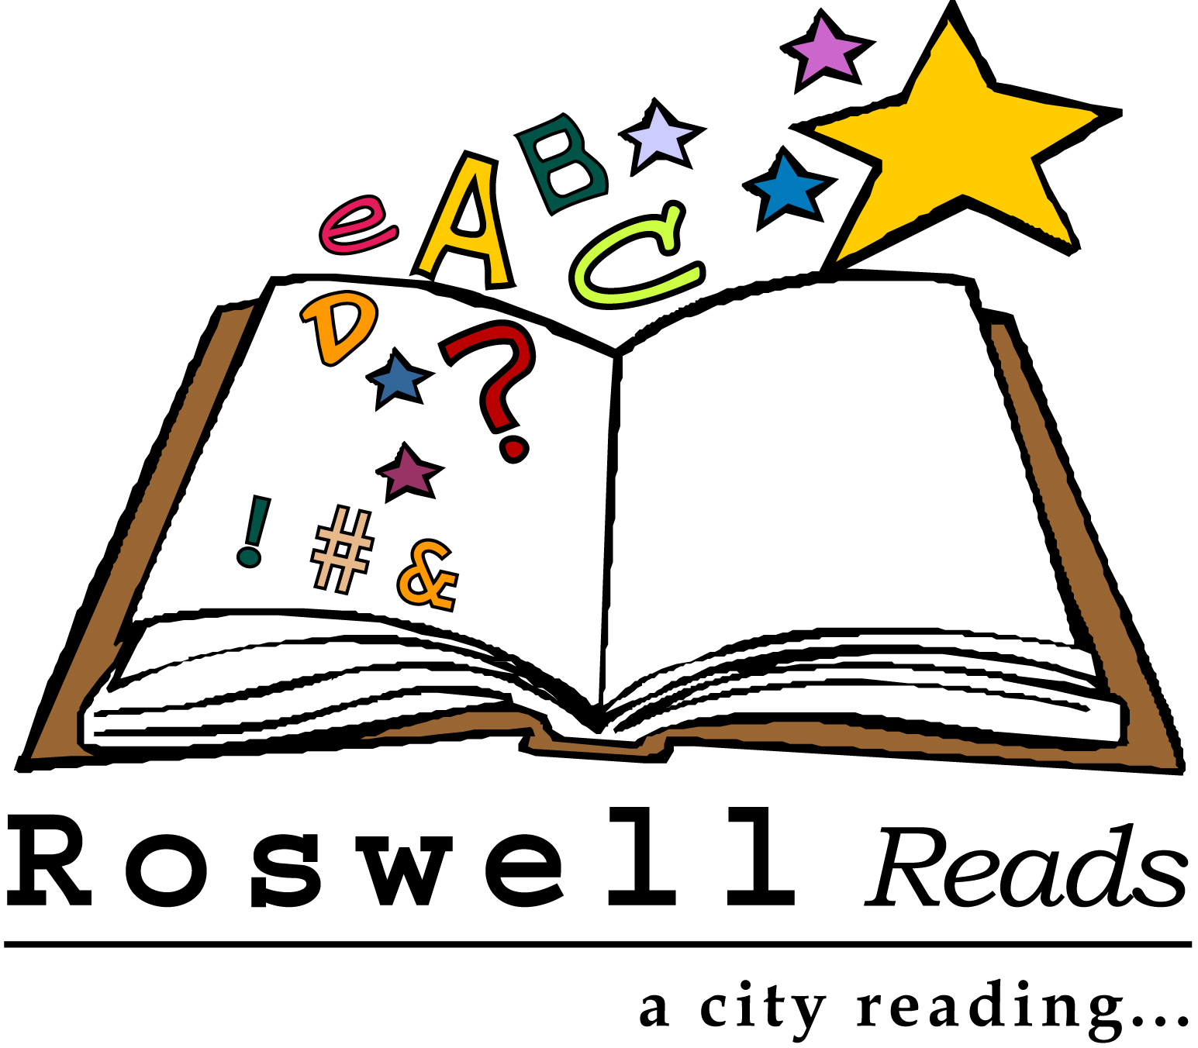

“Roswell Reads Months in Roswell”

Whereas, Reading is an activity of great value to all citizens of all ages and backgrounds; and

Whereas, Many communities across the nation have initiated city-wide reading programs which have helped in building a greater sense of community; have promoted reading throughout the community; and have helped students understand that reading is important both in and out of school; and

Whereas, The Historic and Cultural Affairs Division of the City of Roswell in partnership with the Roswell Library (a part of the Atlanta-Fulton Public Library System), Friends of the Roswell Library, and many community volunteers has established "Roswell Reads: A City-Wide Reading Program;” and

WHEREAS, Additional support for the program has been provided by the Roswell Jr. Woman’s Club, Roswell High School, Centennial High School, and Roswell Rotary Club; and

Whereas, The committee has selected Someone Else’s Love Story by Joshilyn Jackson to be read during the months of January through March 2014; and

WHEREAS, There will be an array of book discussions, programs and events centered around the selected book to enhance everyone’s understanding and enjoyment of it during the months of February and March; and

WHEREAS, There will be a “Literary Luncheon” featuring the Author, Joshilyn Jackson, on Saturday, March 15th, 2014.

NOW THEREFORE, I, Jere Wood, Mayor of the City of Roswell, do hereby
proclaim all of January, February and March 2014 as Roswell Reads months and call
upon all our citizens to recognize this special observance by participating in the Roswell
Reads city-wide reading program.

In witness whereof, I have hereunto set my hand and caused the seal of the City of Roswell to be affixed this 13th day of January, 2014.

JERE WOOD, MAYOR

