STATE OF GEORGIA
1st Reading: May 14, 2012
COUNTY OF FULTON 2nd Reading: May 30, 2012

AN ORDINANCE ADOPTING A BUDGET FOR THE FISCAL YEAR 2013 FOR EACH FUND OF THE CITY OF ROSWELL, GEORGIA, PURSUANT TO ARTICLE VI, CHAPTER 6 OF THE CHARTER OF THE CITY, BEGINNING JULY 1, 2012, AND ENDING JUNE 30, 2013, APPROPRIATING THE AMOUNTS SHOWN IN EACH BUDGET AS EXPENDITURES, ADOPTING THE ITEM OF ANTICIPATED FUNDING SOURCES, PROHIBITING EXPENDITURES TO EXCEED APPROPRIATIONS, AND PROHIBITING EXPENDITURES FROM EXCEEDING ACTUAL FUNDING SOURCES AND AMENDING THE CODE OF ORDINANCES TO EFFECTUATE SUCH ADOPTION.

Whereas, a proposed budget for each of the various funds of the city has been presented to the Mayor and City Council; and

Whereas, appropriate advertised public hearings have been held on the proposed budget, as required by law and regulations; and

Whereas, the Mayor and City Council have reviewed the proposed budget and have made certain amendments to funding sources or appropriations; and

Whereas, each of the funds has a balanced budget, such that anticipated funding sources equal or exceed proposed expenditures; and

Whereas, the Mayor and City Council intend to adopt an annual budget for the Fiscal Year 2013 and a Capital Improvement Plan for the Fiscal Years 2013 through 2017:

Now, Therefore, the Mayor and Council of the City of Roswell, pursuant to their authority, do hereby adopt the following Ordinance:

1.
The City of Roswell, Georgia hereby adopts an expenditure budget for Fiscal Year 2013, said budget being described below and shown on Schedule “A” for each fund of the City of Roswell, Georgia:

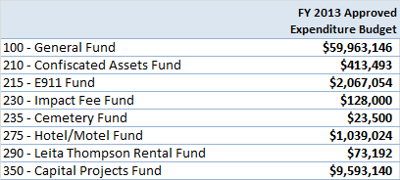

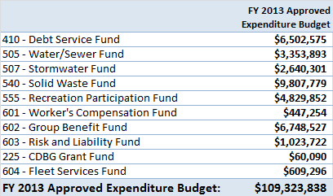

2.
Any increase or decrease in appropriations or revenue of any fund or for any department; the establishment of new capital projects; or the establishment of new grant projects other than those exceptions provided for herein, shall require approval of Mayor and City Council.

3.
A millage rate of 5.455 mills is hereby established as part of the approved budget based on the estimated digest of Fulton County. The millage rate has a component of 4.059 for the General Fund and a 1.396 component for the General Obligation Bond Debt Fund. This millage rate may be adjusted at a future date based on receipt of a certified digest.

4.
This budget fixes the number of budgeted full-time positions of the City at 594. This number may only be increased or decreased through approval of the Mayor and City Council. The City Administrator or his/her designee is authorized to create policies and procedures for the number, pay grade, classification, and/or cost center location, which may be changed throughout the year.

5.
Mayor and Council further also adopt a Capital Improvement Plan for Fiscal Years 2013 through 2017 as attached hereto and incorporated herein as Schedule “B.” This plan does not indicate any promise of appropriations for future years. This plan may only be modified through action of Mayor and City Council.

6.
Mayor and Council further approve the re-appropriation of all available funds for FY 2012 approved capital projects that have not been completed as of June 30, 2012.

7.
Mayor and Council further approve the re-appropriation of the $468,000 approved in FY 2012 for Pension Plan transition costs.

8.
The City Administrator and his/her designee may promulgate all necessary internal rules, regulations, and policies to ensure that this Budget Ordinance is followed.

The above Ordinance was read and approved by the Mayor and Council of the City of Roswell, Georgia on the 14th day of May and the 30th day of May, 2012.

Attest: Jere Wood, Mayor

Marlee Press, City Clerk
(Seal)

Councilmember Jerry Orlans Councilmember Rebecca Wynn

Councilmember Betty Price Councilmember Richard Dippolito

________________________________

Councilmember Kent Igleheart Councilmember Nancy Diamond

