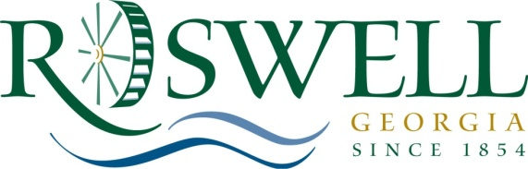

M E M O R A N D U M

TO: Mayor and City Council

FROM: Alice Wakefield, Community Development Director

DATE: May 29, 2012

SUBJECT: Economic Development Incentive Policy - Amendment

On May 29, 2013, the Committee approved moving the proposed amendment to Economic Development Incentive Policy to the June 10, 2013 Mayor and City Council meeting with changes. Therefore, staff is asking City Council to approve revised Economic Development Incentive Policy with the following amendments:
- Amend the number of jobs created to five (5) jobs or more instead of fifty (50) or more jobs.
- Amend the required capital investment amount from $15 million to an undetermined amount.
- Expand the Economic Development Incentive Committee to include the Council Liaison to the Community Development Department.
- Revise the wording in the compliance section by removing the works related to audit and the sentence regarding repayment.
- Allow the Economic Development Incentive Policy Committee to approve incentive requests under $25,000.

Attachments:
Resolution
Economic Development Incentive Policy – Mark-Up
Economic Incentive Analysis form

