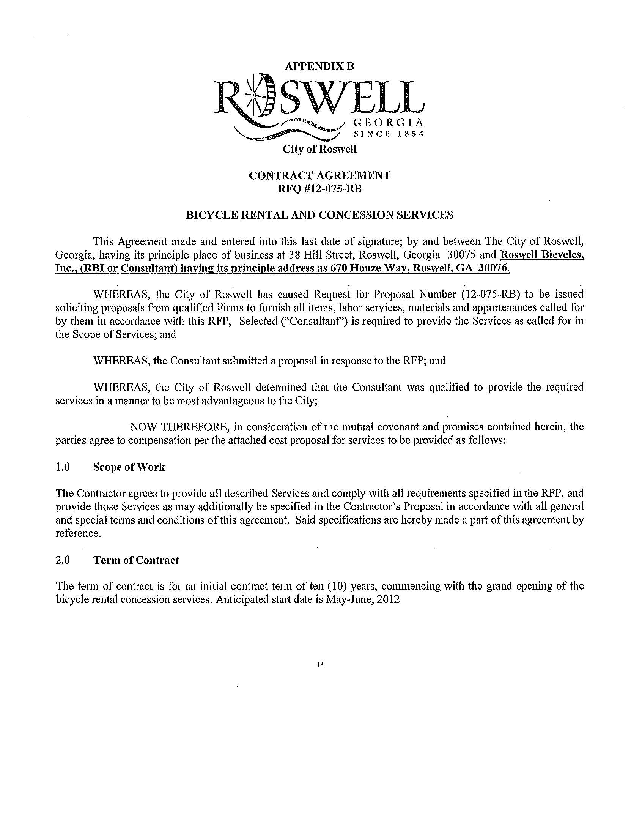

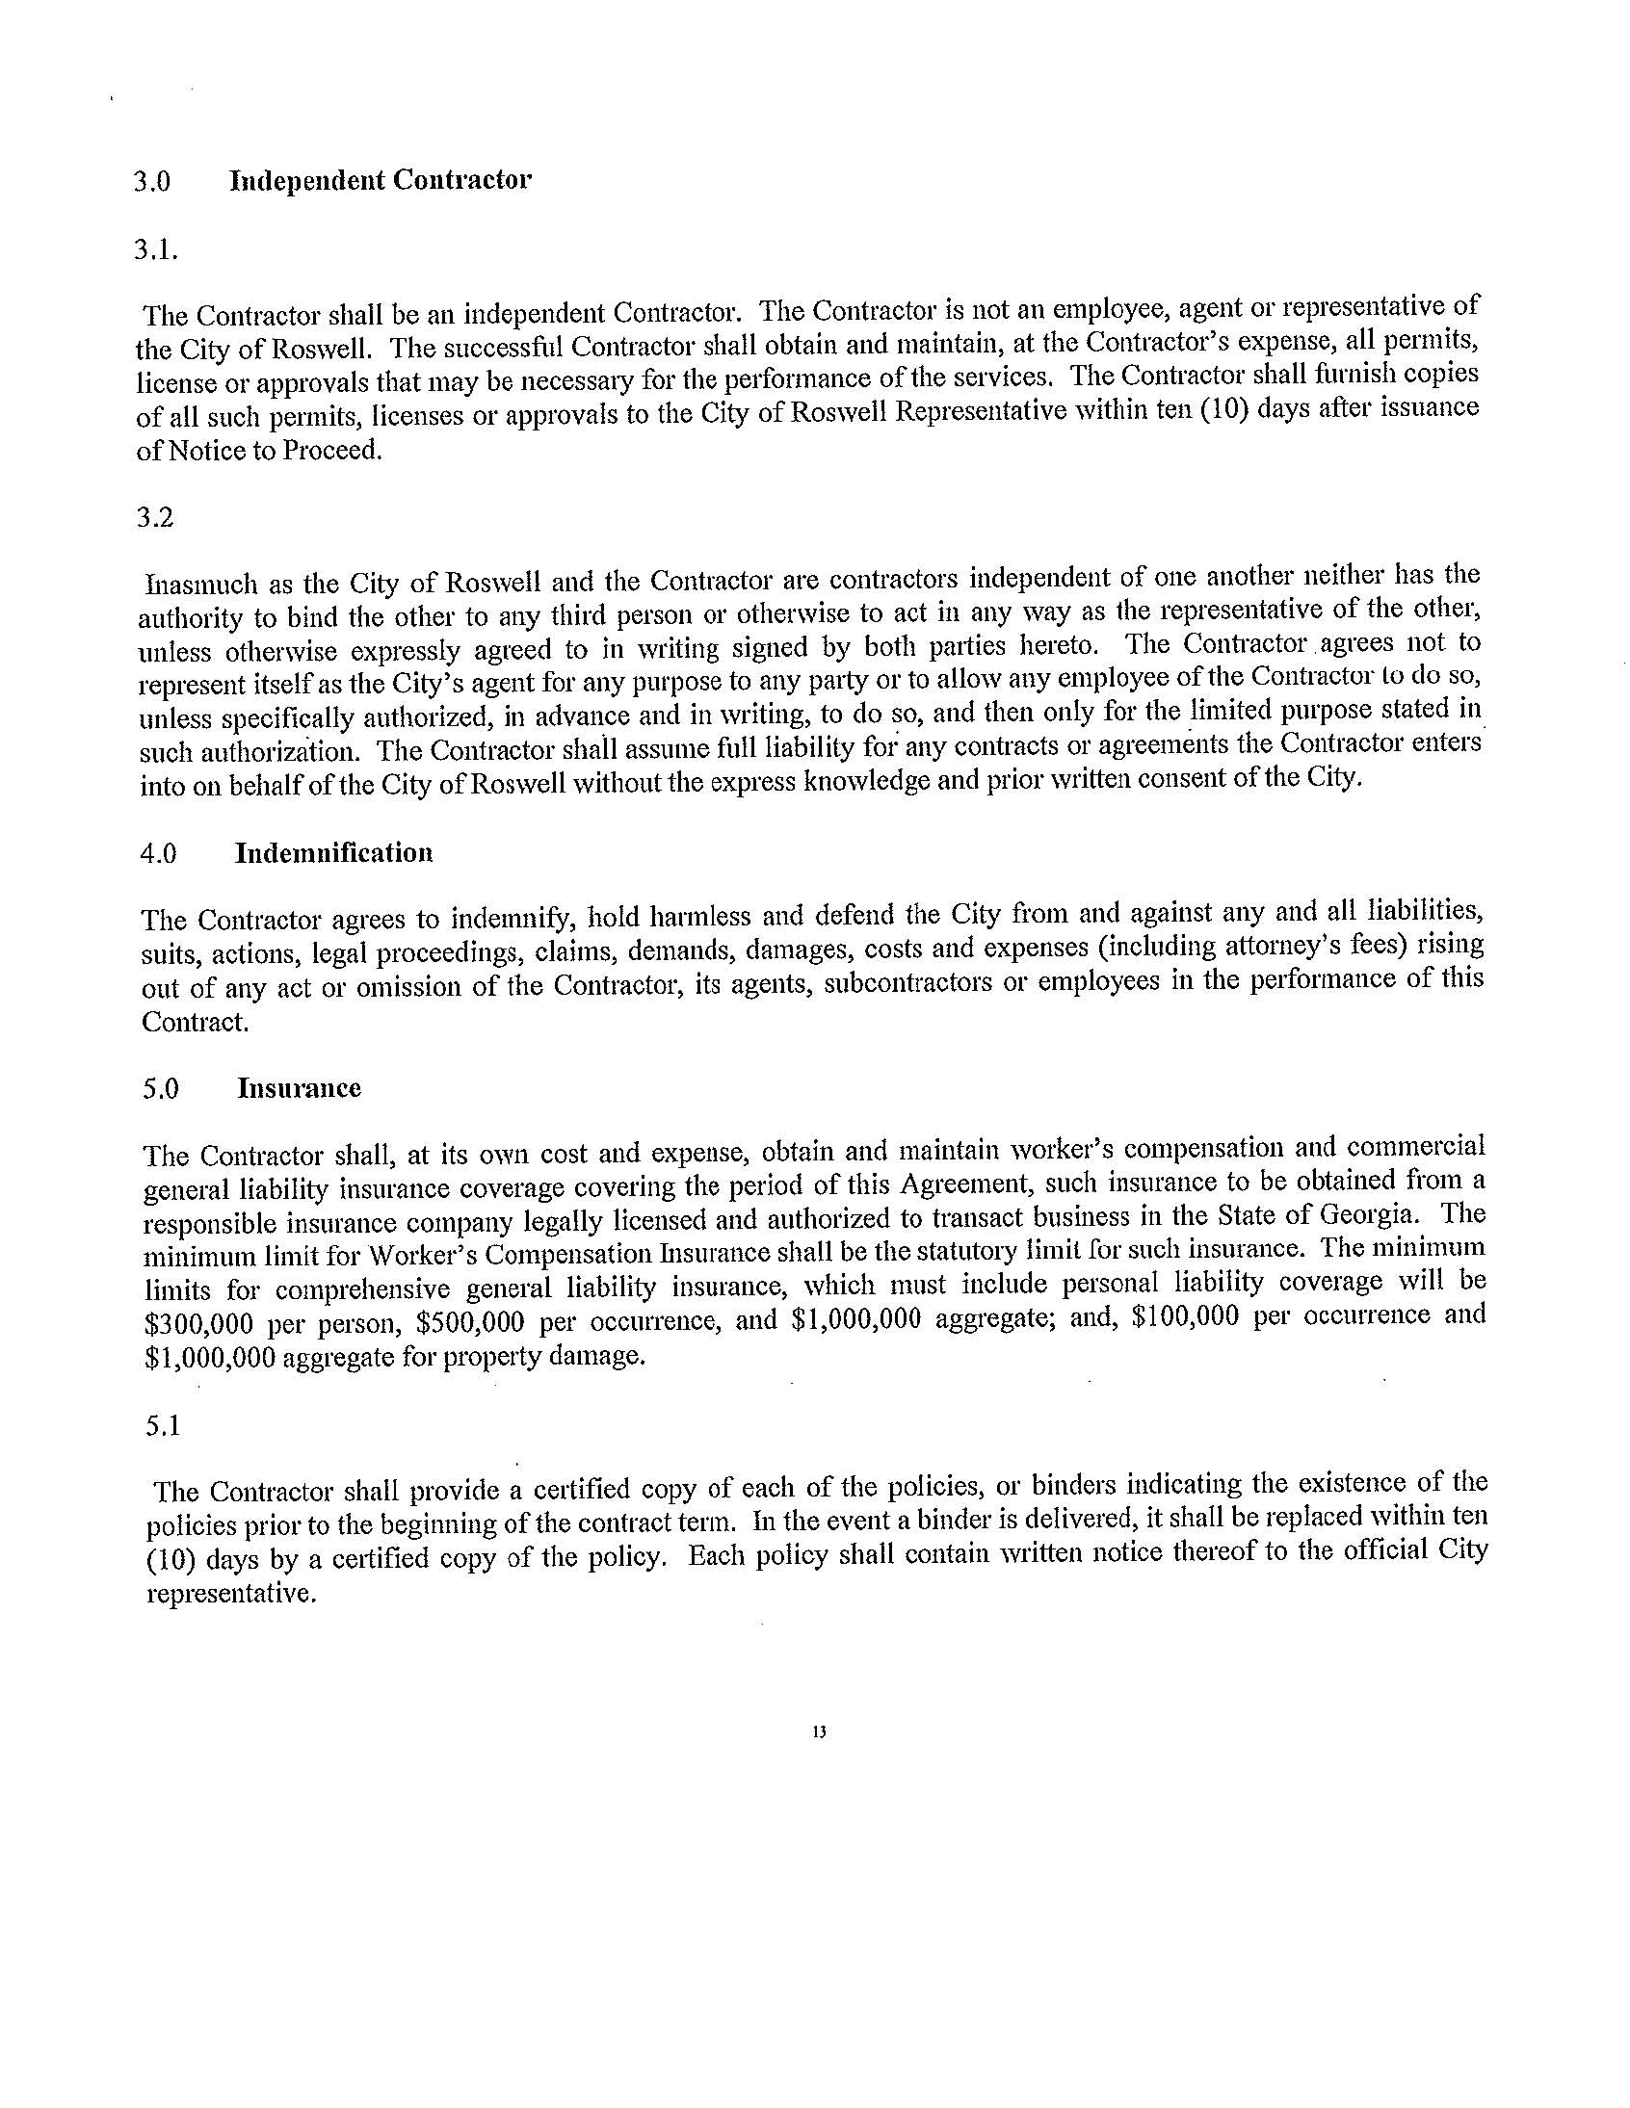

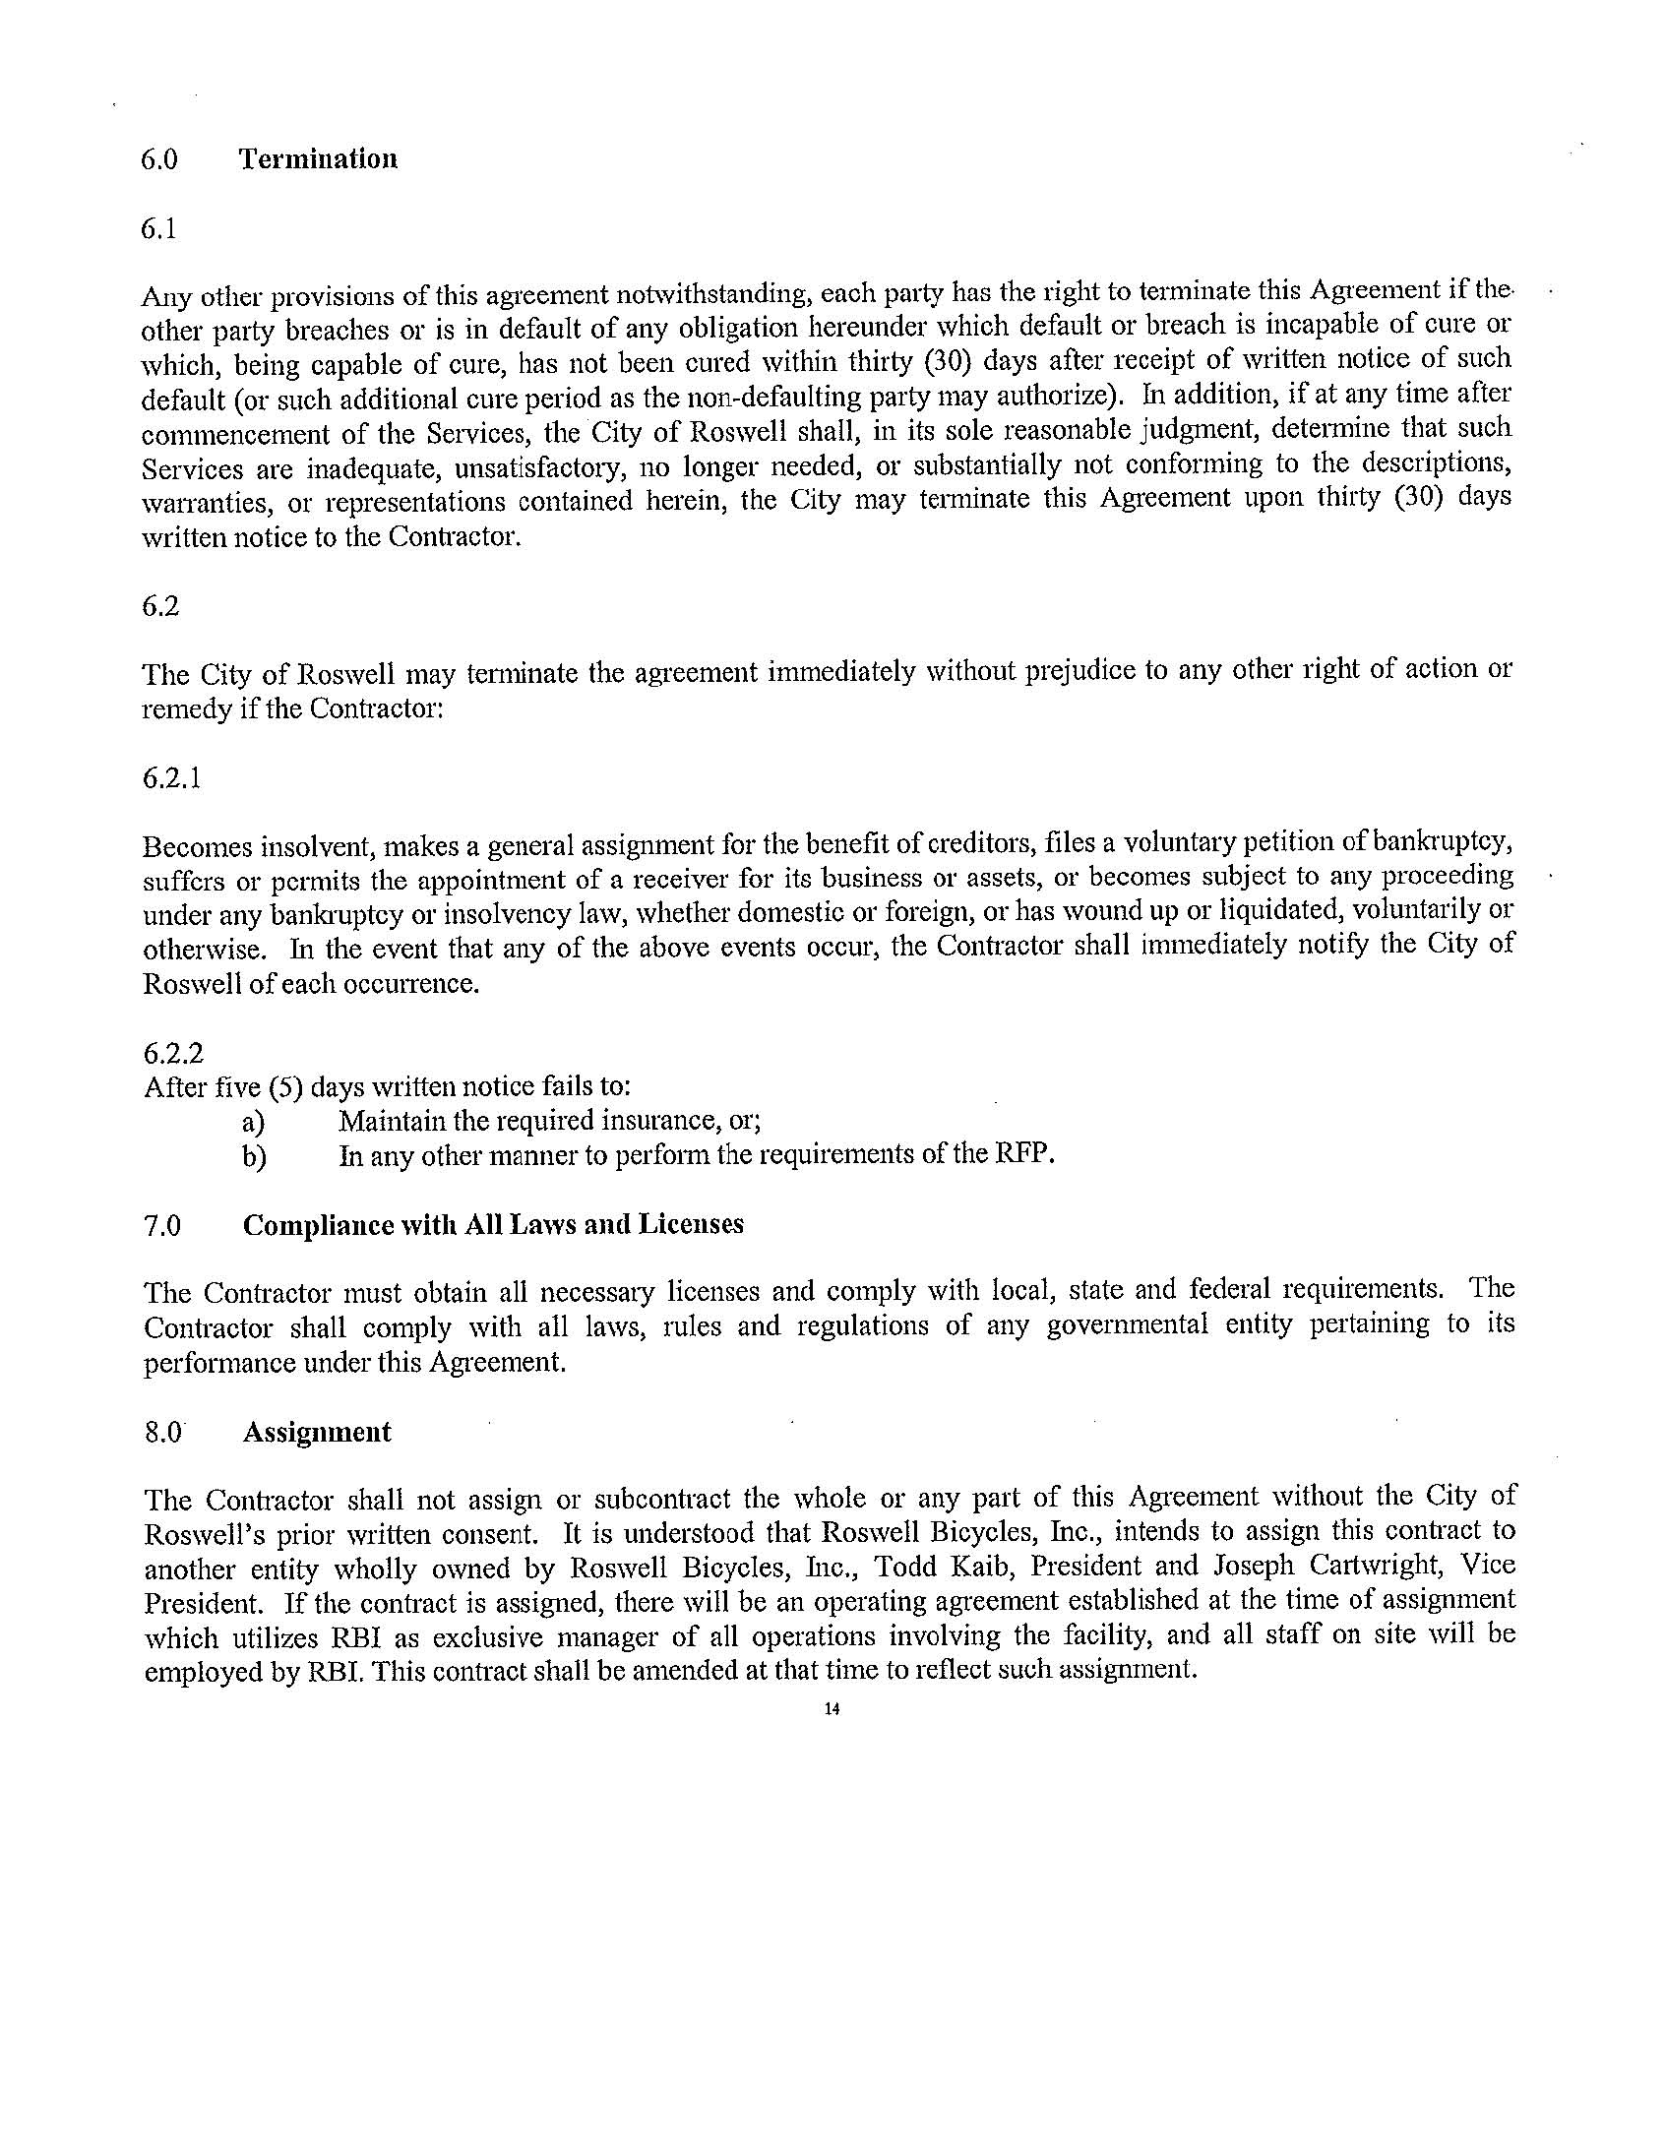

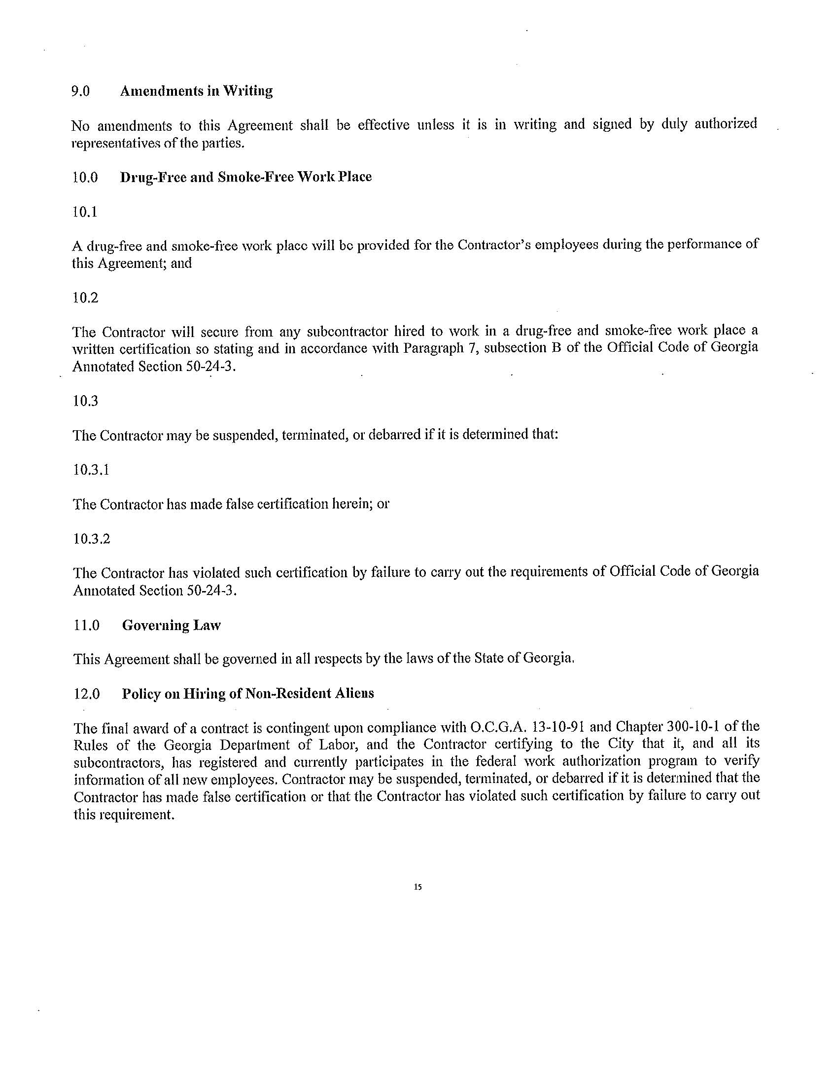

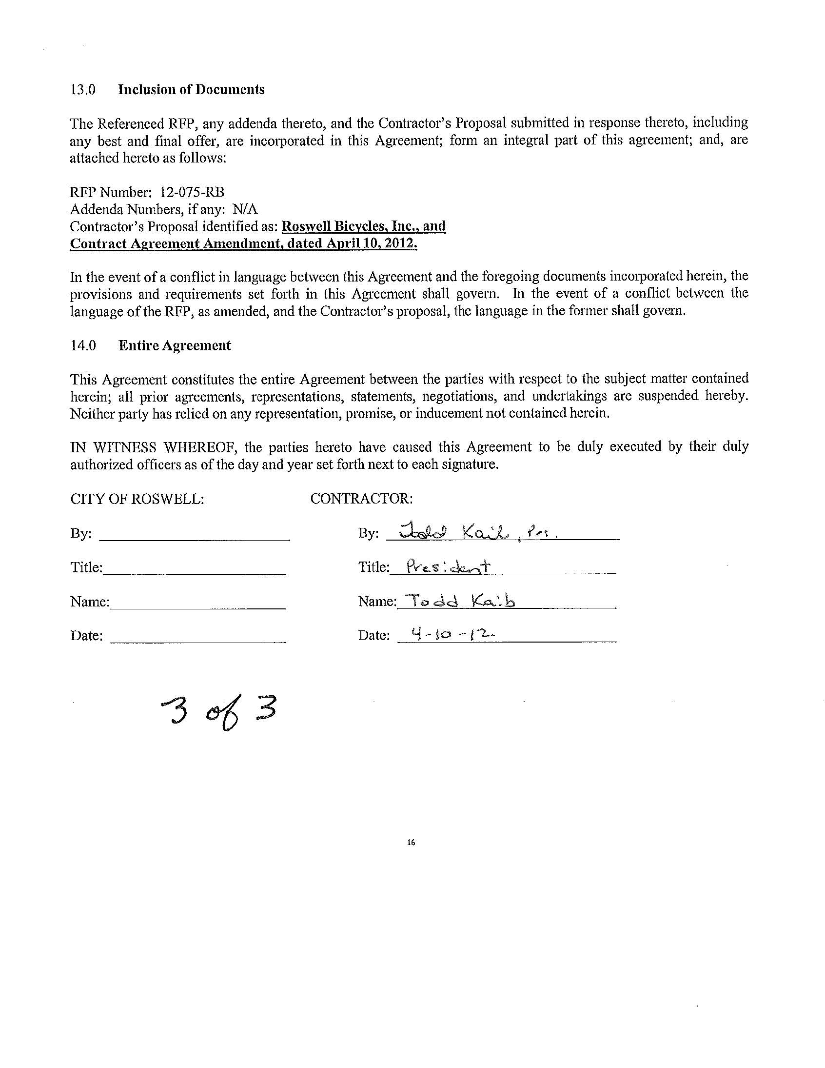

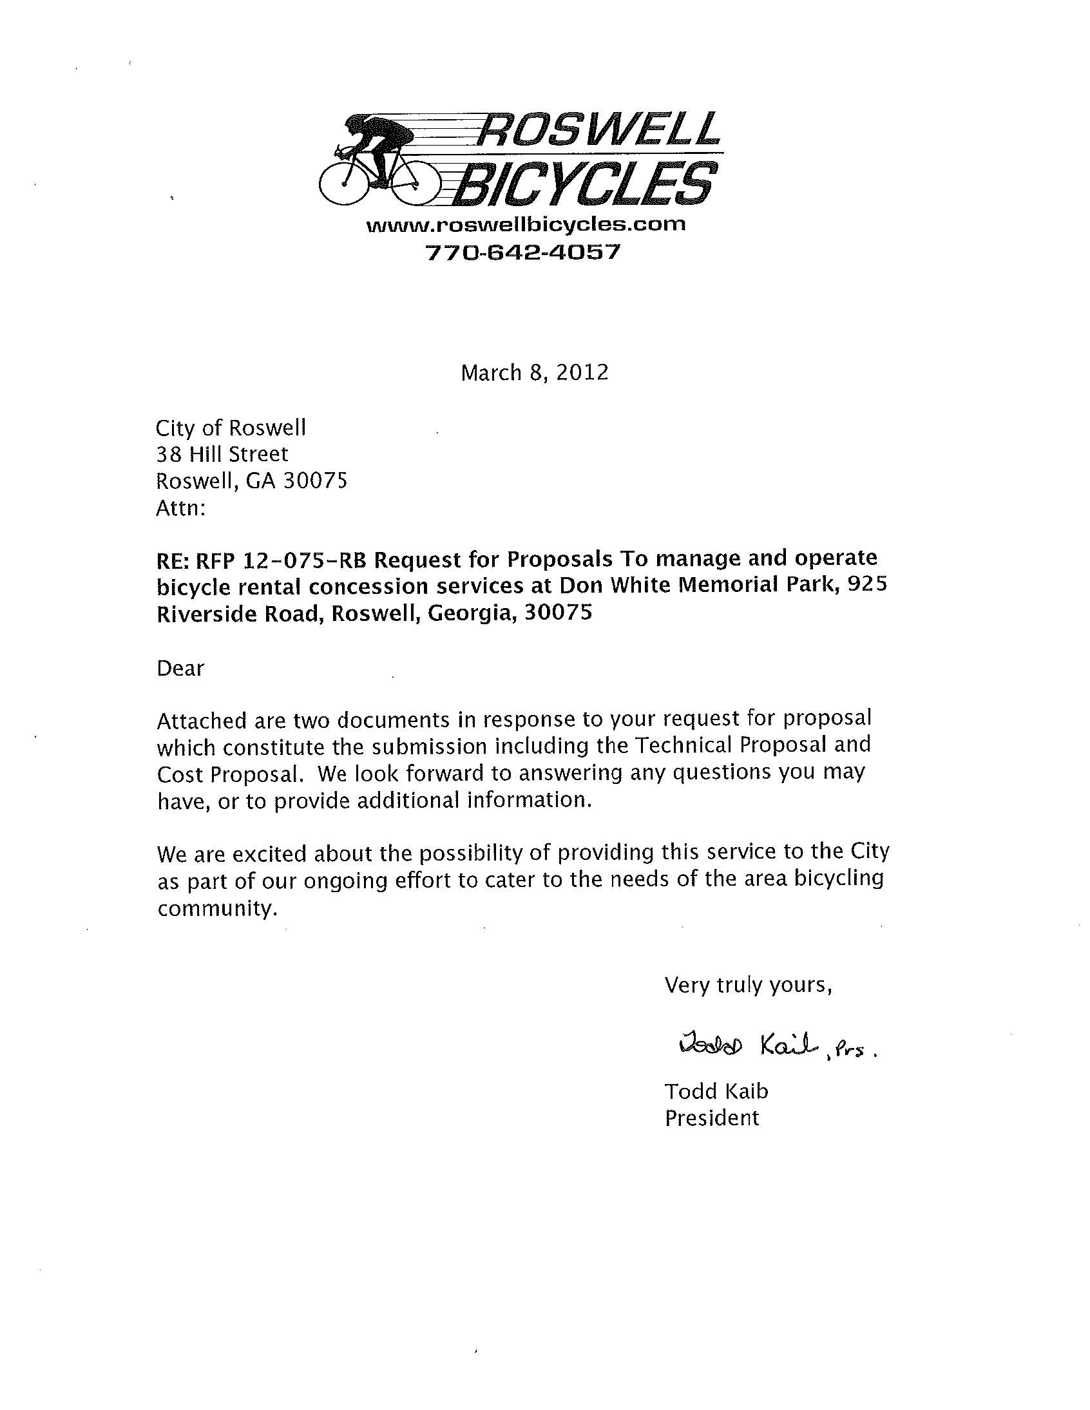

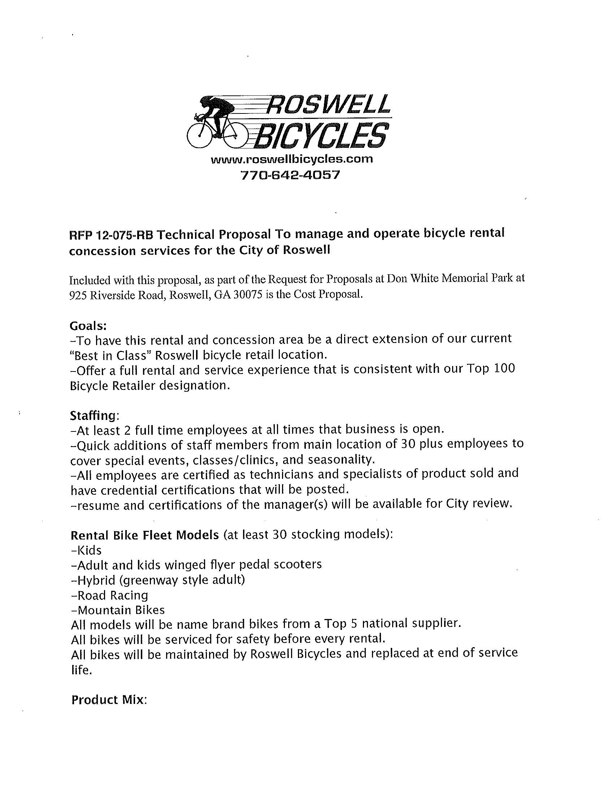

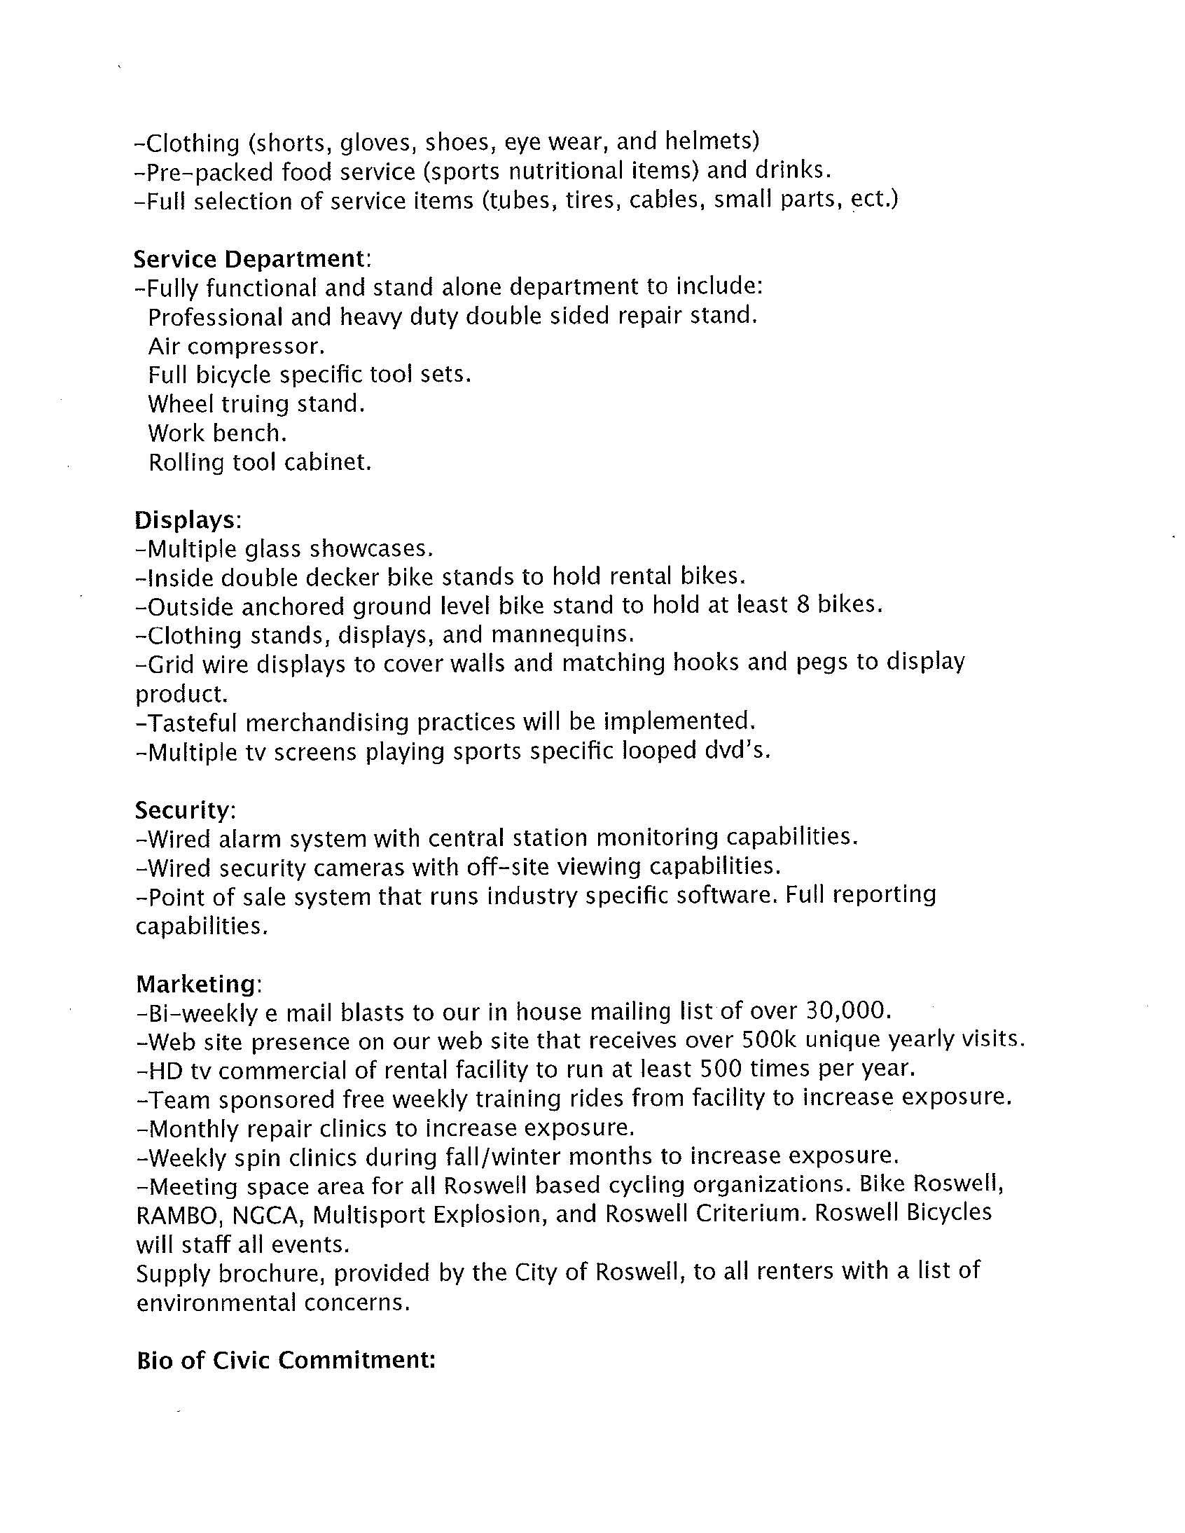

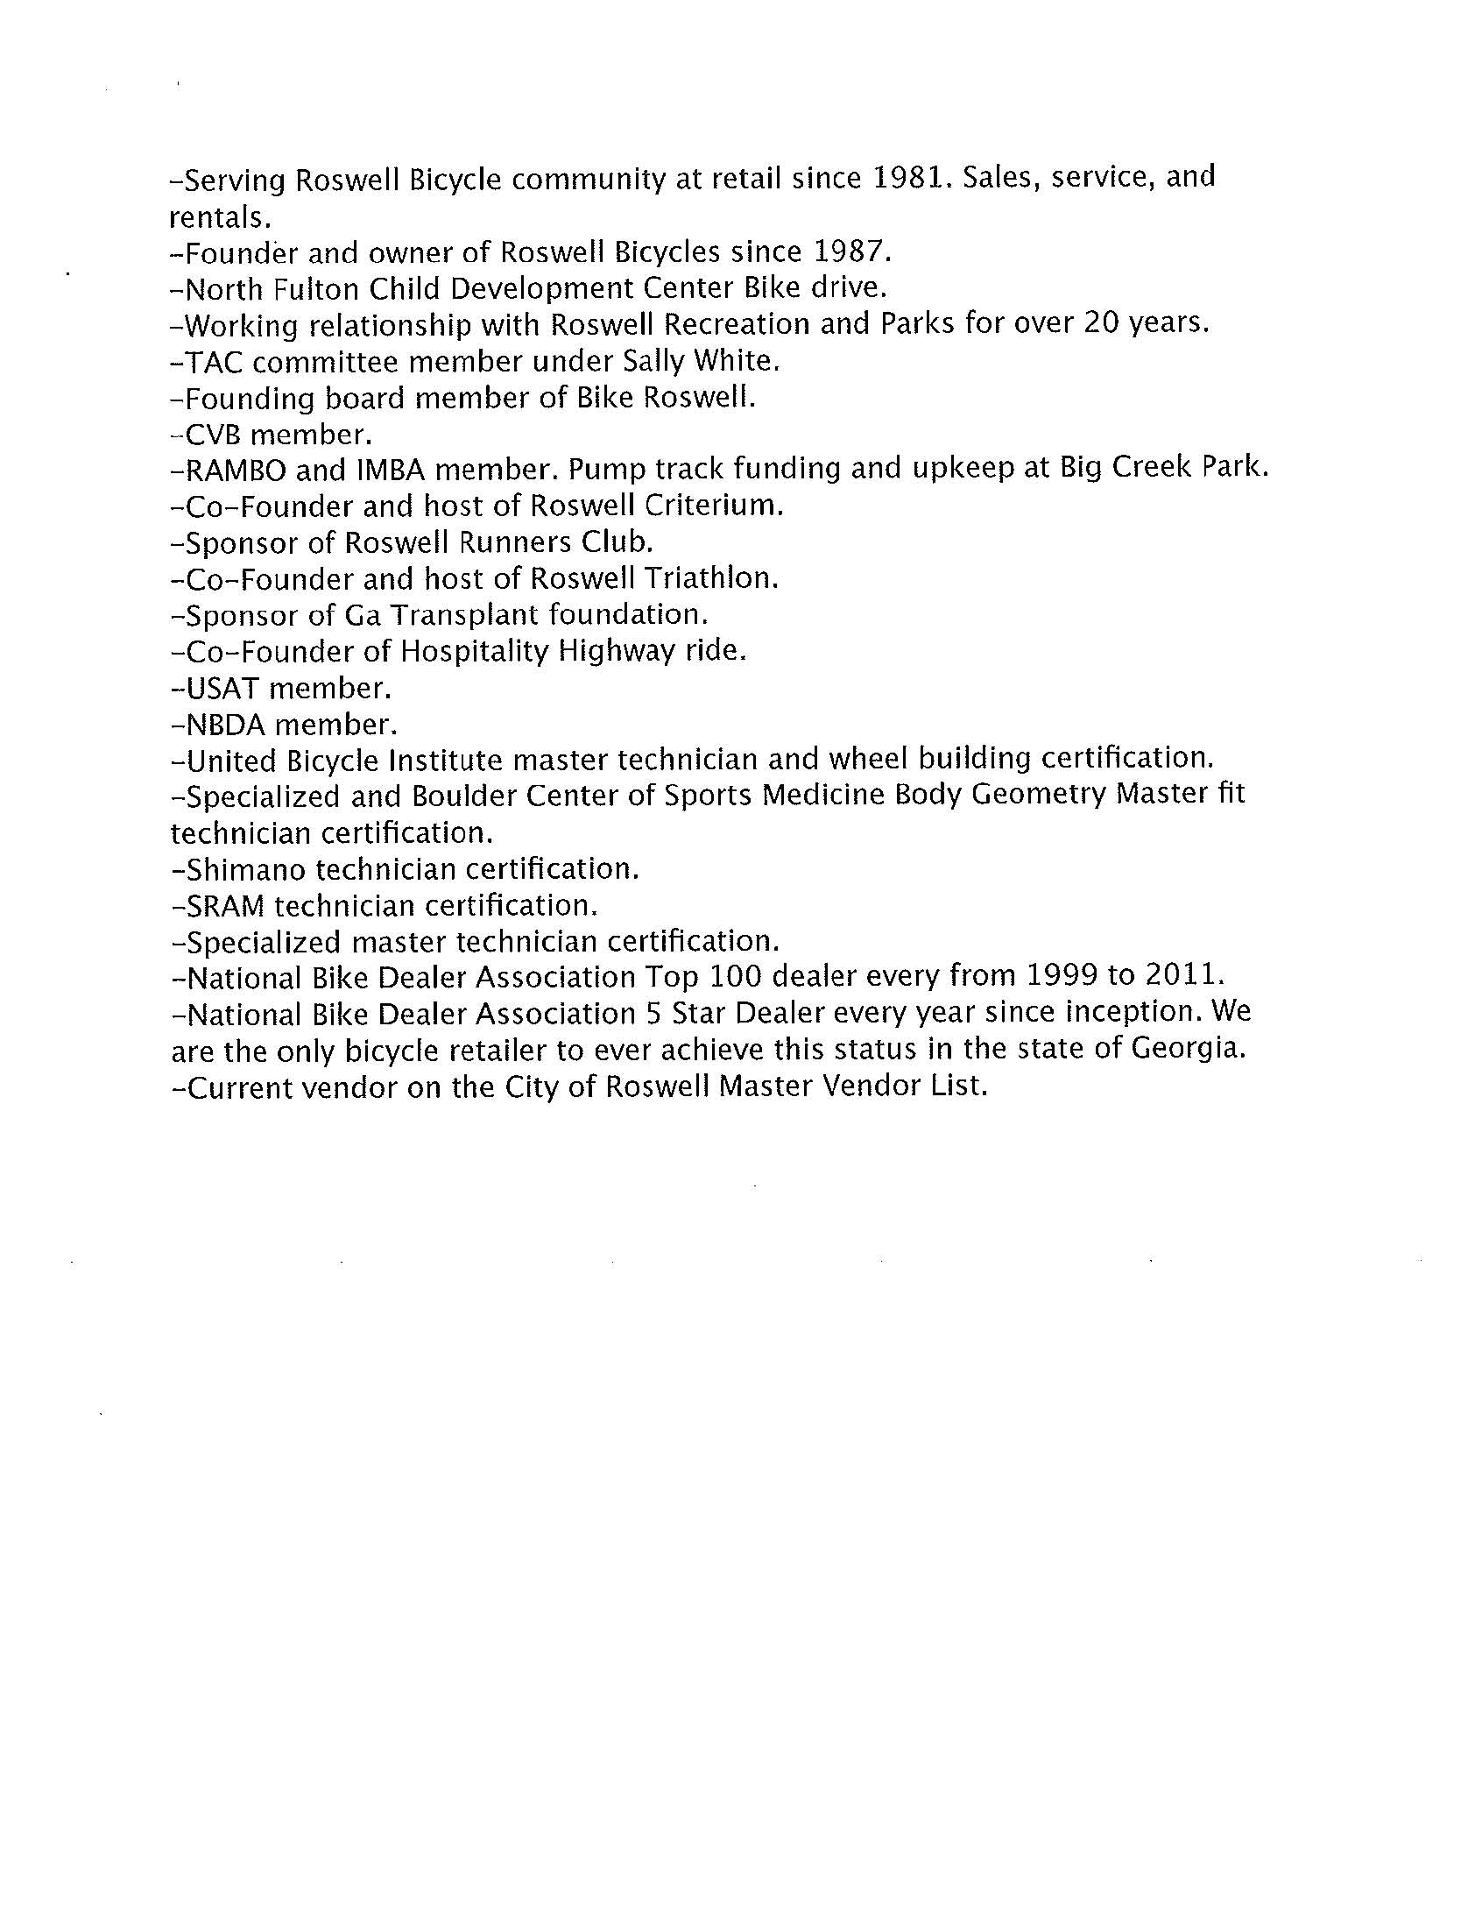

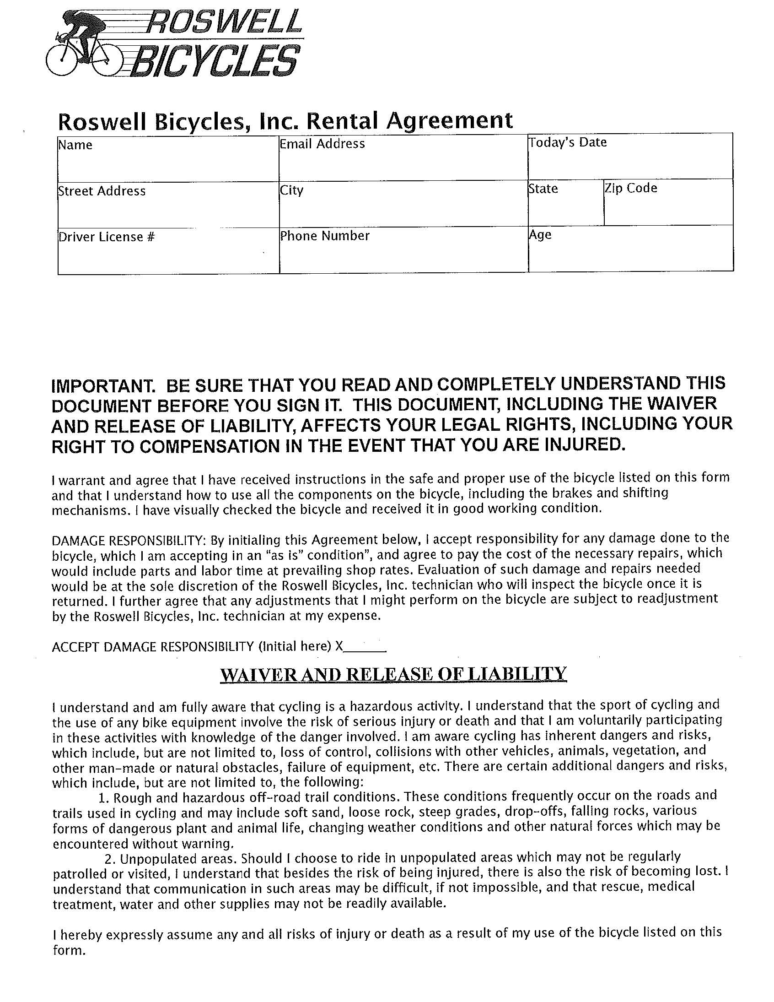

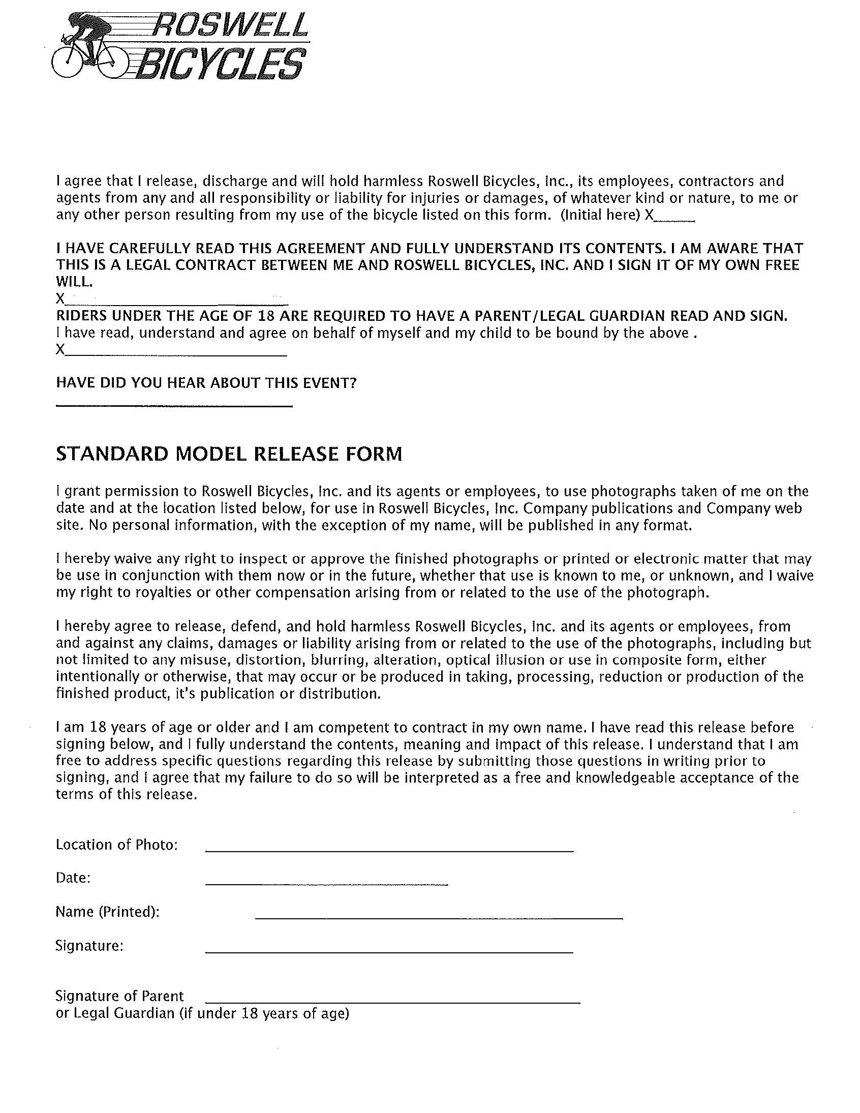

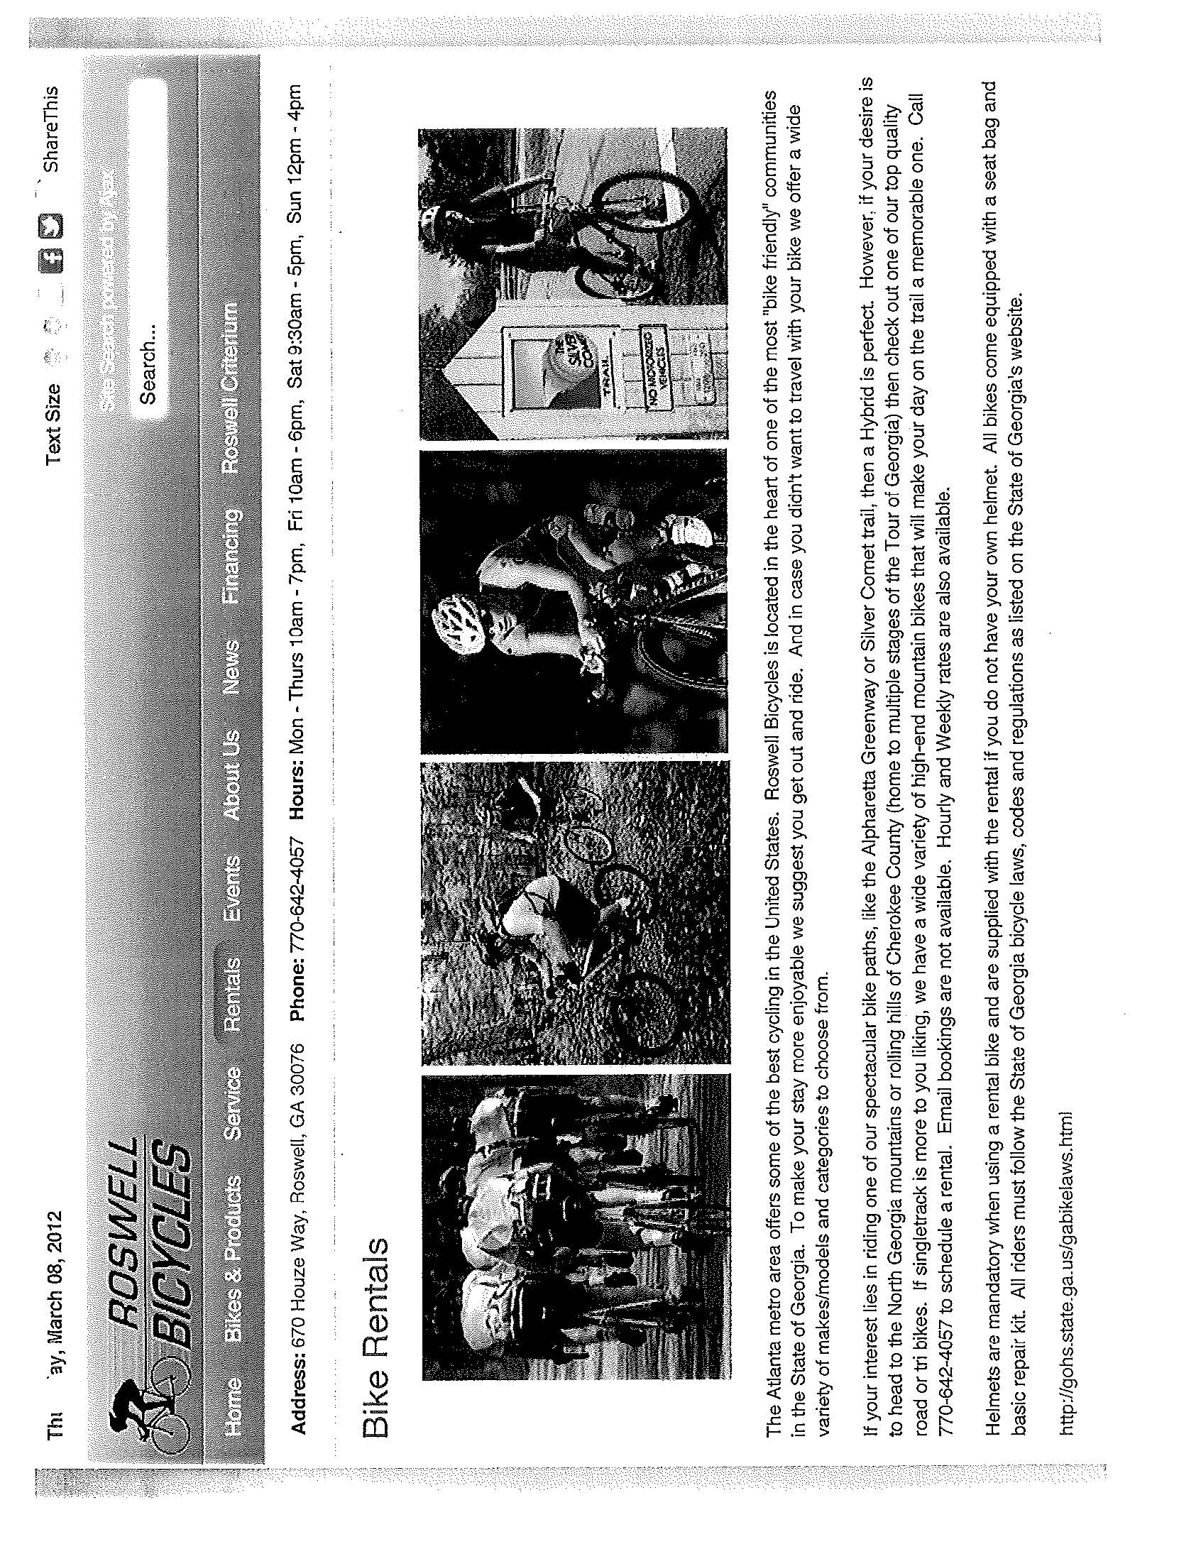

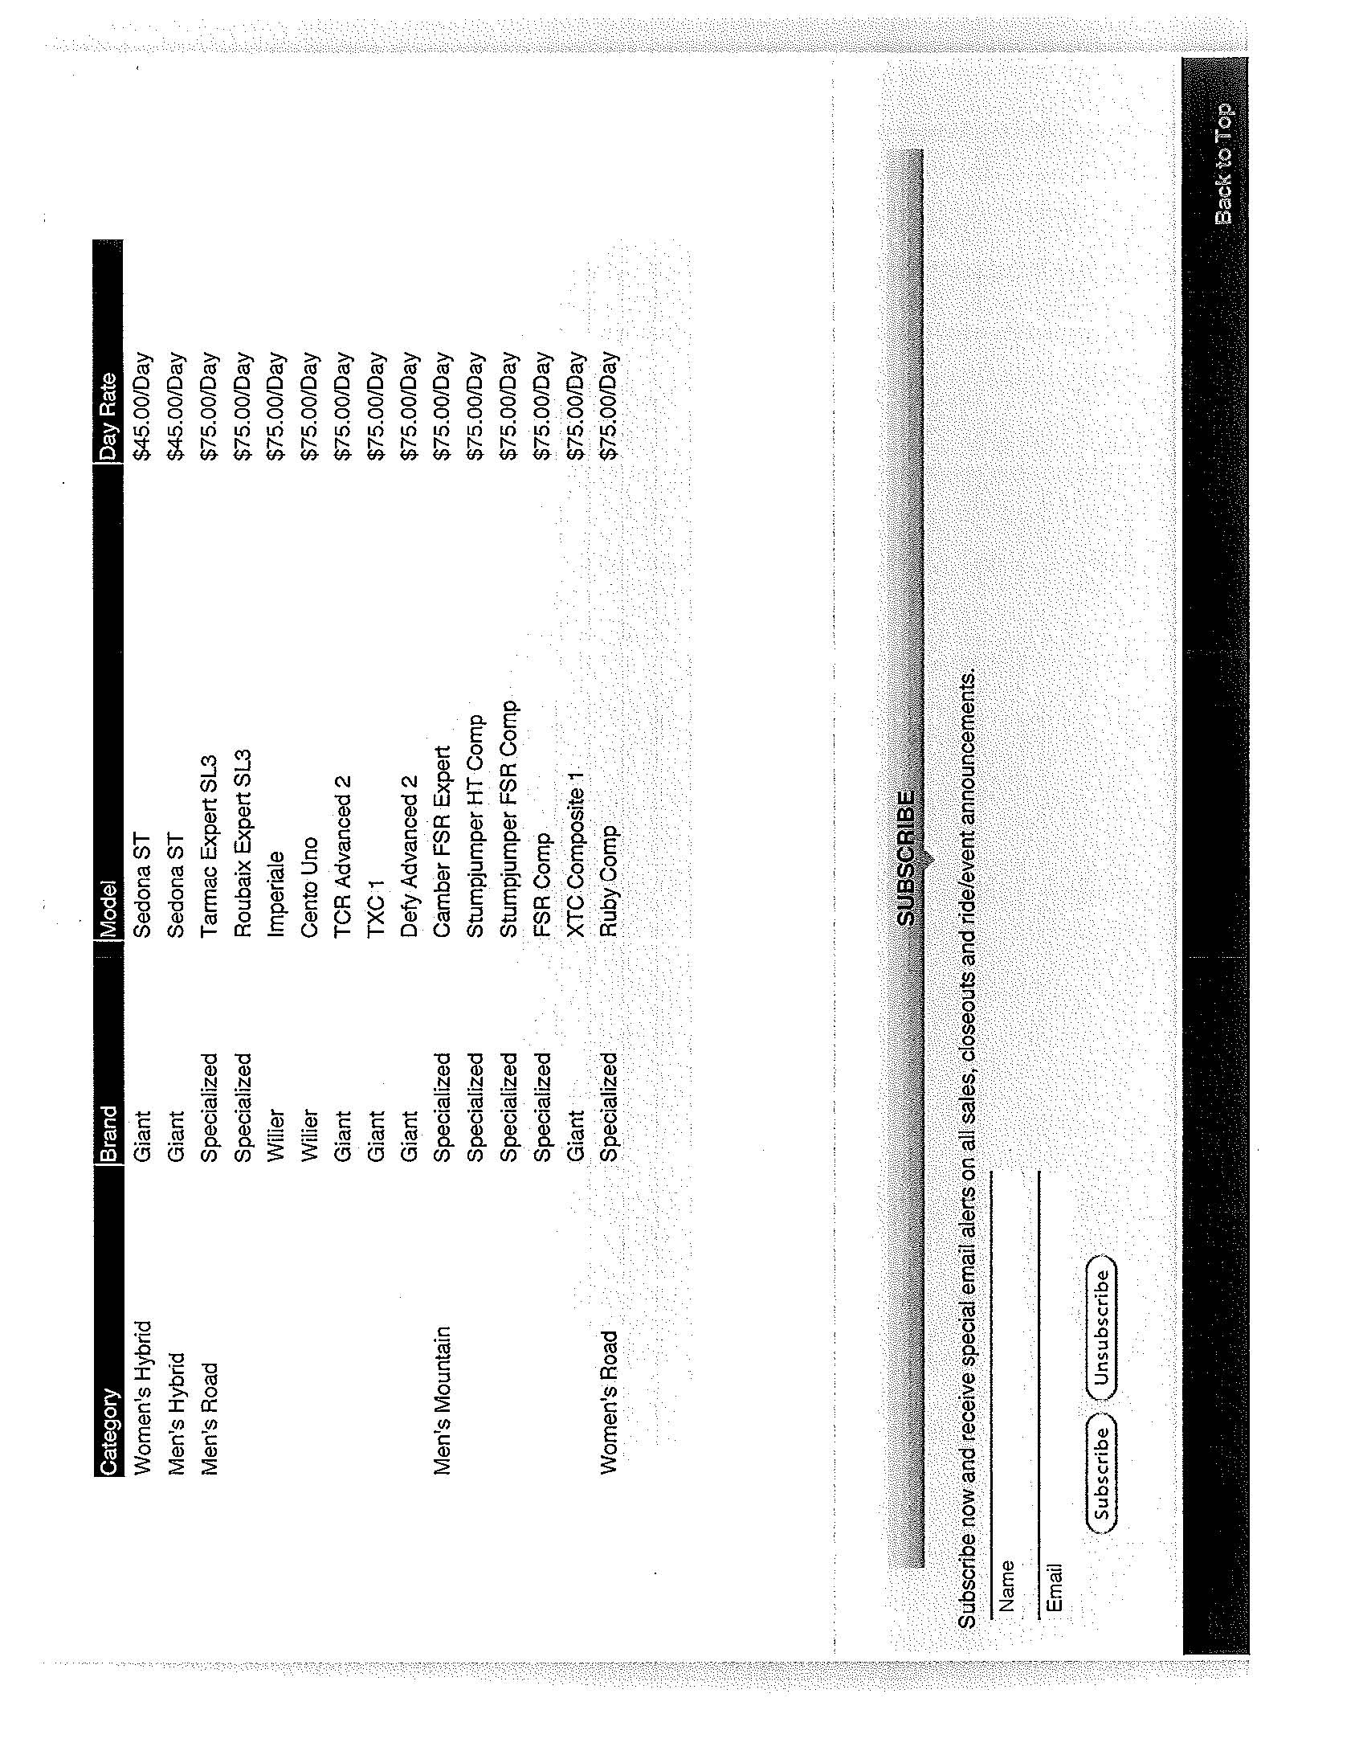

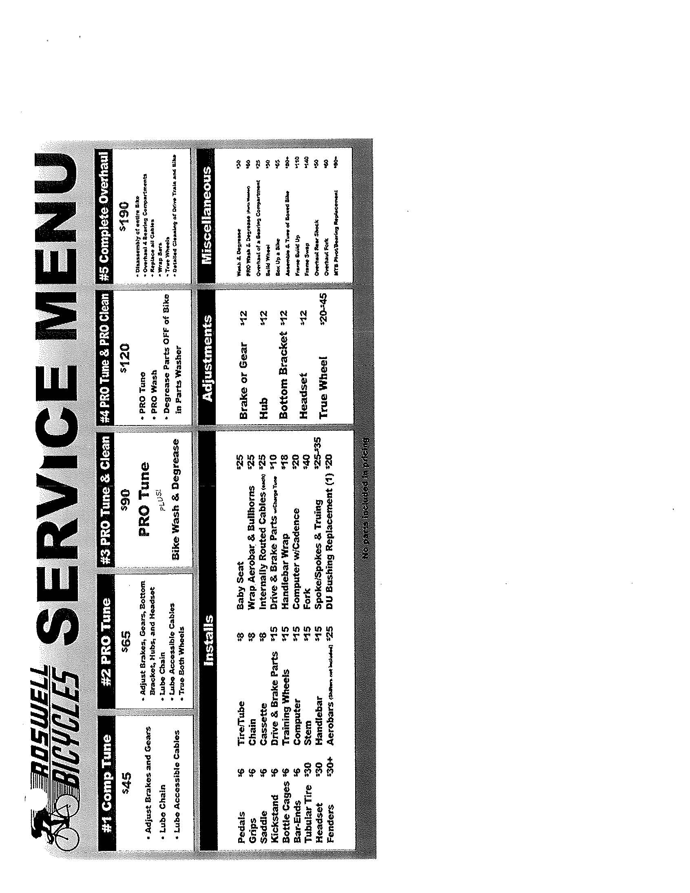

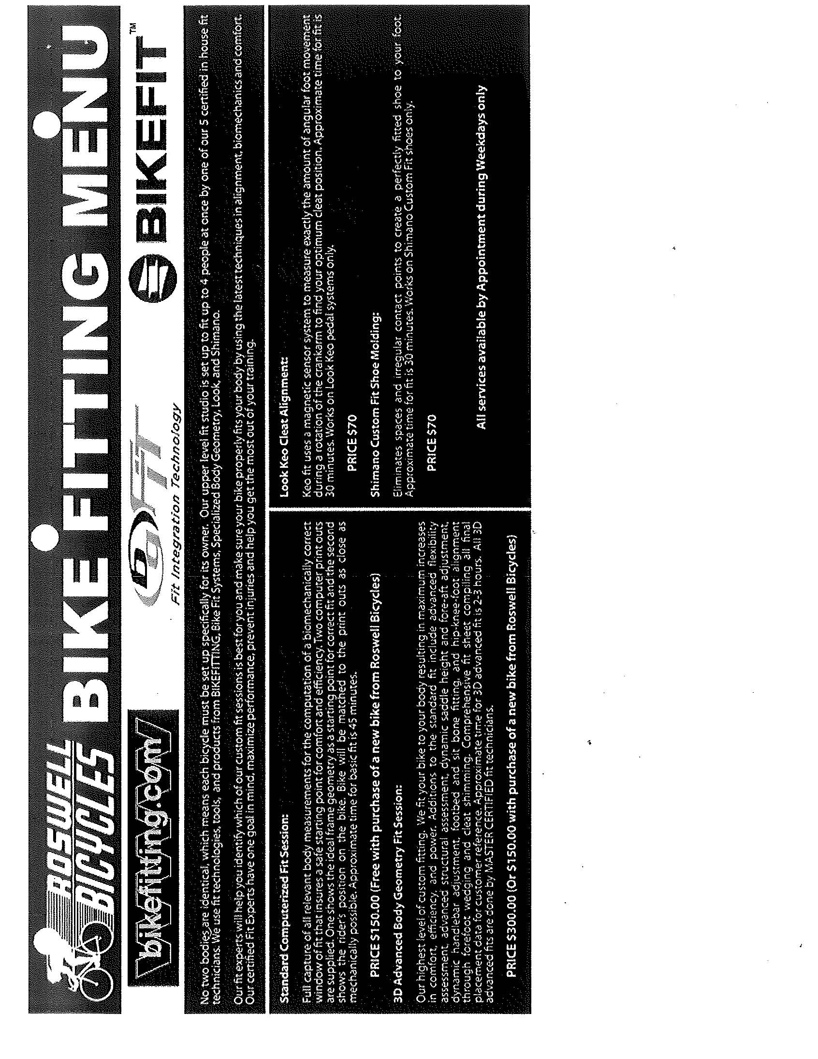
CONTRACT AGREEMENT AMENDMENT
April 10, 2012

Contract amendment to manage and operate bicycle rental concessions services for the City of Roswell at Don White Memorial Park at 925 Riverside Road, Roswell, GA 30075.

This contract is between Roswell Bicycles, Inc. (RBI) and the City of Roswell Recreation and Parks Department (City).

- The term of this contract is ten years commencing with the grand opening of the bicycle rental concessions services with renewal options for one or more years.

- RBI agrees to pay rent of 5% of gross sales, with a minimum of $1,500, and a maximum of $2,000 rent per month. Rent will be paid quarterly supported by the sales tax reports for that quarter.

- The City agrees to do the following:
  - Remove all trash from premises
  - Trim overgrown shrubbery around building
  - Remove growth between building and road as possible
  - Provide space for adequate signage for advertisement and directions.

- RBI agrees to upgrade the building as needed to include, but not limited to, the following:
  - Rehabilitate mechanical, electrical and plumbing services in accordance with the City of Roswell Codes that have not already been completed by the City’s Facility Condition Assessment Program.
  - Place motion flood lights on all four corners of the building
  - Replace lighting throughout the building as needed.
  - Seal basement floors
  - Paint interior of the building
  - Other work as approved by RBI and City

- The cost of the repairs and improvements as outlined in #4 shall be paid by RBI. RBI will deduct the invoiced amounts of approved improvements and repairs from the monthly fee due as outlined in #2 above until the improvements and repairs have been paid in full.

- Failure by RBI to pay the rent or substantially perform the scope of services under that attached Technical Proposal will be considered a default and may result in termination of the lease. The City will provide written notice of default and include a reasonable period for RBI to correct the default. The City agrees that provided this lease remains in effect, that RBI will be the exclusive provider of rental equipment for this Park.

- RBI shall carry $1 million of liability insurance, workers compensation insurance, content insurance, and secure all necessary operating permits and licenses from the appropriate regulating authority.

- RBI may sub lease part of the premises to properly licensed and insured users for compatible use with approval by the City.

- RBI will be responsible for all interior maintenance except mechanical, electrical and plumbing systems installed by the City. Any damage caused by RBI will be the responsibility of RBI. Exterior maintenance shall be the responsibility of the City including roof, exterior paint, and landscape maintenance. RBI

- RBI shall be responsible for utilities.

- City shall be responsible for property taxes, and insurance on the structure.

- RBI shall have access to the front of the house through the street side as well as the rear of the house through the gate behind the public rest rooms for deliveries and occupants.

- RBI shall be permitted access for activities outside normal park hours. RBI must notify the City of after normal park hour activities.

- RBI shall be permitted to place a sign in the front of the house along Riverside Road, provided it meets City standards. Non-frontage signs on the sides and rear of the house will be allowed.

- City agrees to participate in cross-promotional activities. Service classes, training rides, and clinics will be included in City programs, brochures, web site, emailers, and postings at other Park areas and kiosks.

- City assumes all liability for flooding and sewer damage unless flooding and sewer damage are caused by RBI. RBI shall be responsible for flood insurance on the contents of the building.

- Hours of operation will be determined by RBI.

- RBI shall report accidents requiring medical care to the City within 24 hours.

- RBI will be given a 90 day window to perform the build out of the location from the award date of bid to ensure a professional grand opening. Rent will start at the official grand opening.

- This contract is assignable by Roswell Bicycles, Inc., to another entity wholly owned by Roswell Bicycles, Inc., Todd Kaib, President and Joseph Cartwright, Vice President. If the contract is assigned, there will be an operating agreement established at the time of assignment which utilizes RBI as exclusive manager of all operations involving the facility, and all staff on site will be employed by RBI.

