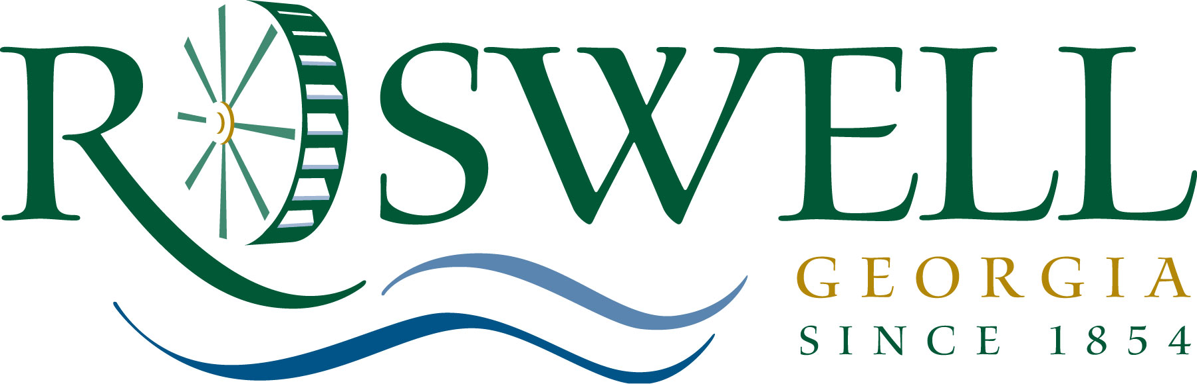

To: Mayor & Council

From: Dan Roach, Human Resources

Re: 2012/2013 Employee Group Benefits

Date: July 18, 2012
________________________________________________________________________

Please consider the following recommendations for group health care benefits for the period of October 1, 2012 to September 30, 2013 for approval at the August 13, 2012 Mayor & Council Meeting. The recommendations are within budget constraints.
Recommendations:

An RFP was issued and invitations to bid were solicited from all major insurance providers in the marketplace for group health insurance and all ancillary lines of coverage. Bids were received and evaluated on the basis of coverage levels, disruption rates, price, short and long term funding strategy and competitor benefits.

Medical Coverage: The City’s claims experience for the prior service year, coupled with difficult market conditions, resulted in a “status quo” renewal from our incumbent carrier at a proposed rate increase from 24%, to 10% and finally to 3% over last year. Bids received from other carriers for “status quo” coverage ranged from no increase to a 0.45% decrease, with several carriers electing not to bid.

In order to provide medical coverage in a cost effective manner for the upcoming plan year, as well as in the short term, we need to align ourselves with the best carrier in order to identify cost savings and promote wellness, while minimizing the impact upon our employees and their families.

The recommendation is to bind coverage with Aetna for an HRA (Health Reimbursement Arrangement) and an HSA (Health Savings Account) for medical insurance coverage for all eligible employees, with a combined decrease of 0.45%. These plans are high deductible, consumer driven plans with the same plan design offered last year.

- HRA (Health Reimbursement Arrangement) - The premium split will remain the same, at approximately 16% paid by employees and 84% paid by the City. City of Roswell employees will continue to retain the present HRA fund at $500/employee only and $1,000/family. The deductibles for the HRA will remain the same at $1,500/employee only and $3,000/family. This will be the 2nd year employees are asked to participate in co-insurance, with a 10% employee share and 90% plan share on medical expenses after the deductible has been met and until the out-of-pocket maximum has been reached.

- HSA (Health Savings Account) – The premium split will remain the same, at approximately 8% paid by employees and 92% paid by the City. The City of Roswell employees will have an HSA fund of $750/employee only and $1,500/family. Deductibles will be $2,000/ employee only and $4,000/family. After the deductible is met, co-insurance, for the 2nd year, is 10%/90% ratio as described under the HRA plan above, up to an out-of-pocket maximum of $3,000 for employee only coverage and $6,000 for family coverage

Ancillary Benefits:

Short (STD) & Long Term Disability (LTD): The current incumbent, The Standard, proposed a 5.8% decrease, while Aetna’s proposed amount was 19.5% decrease to provide benefits for Short Term Disability (STD) and Long Term Disability (LTD) coverage. Combining this benefit with the others with Aetna will result in a larger savings. Total cost is $106,968, which represents a $25,965 savings.

Life Insurance: The current incumbent, The Standard, proposed no increase. However, Aetna proposed a 16.4% decrease. Aetna is recommended to provide basic and voluntary life insurance benefits, as well as accidental death and dismemberment coverage. Employees pay the total cost for any additional voluntary life benefits. The premium for basic life including enhanced accidental death and dismemberment coverage will be $87,298, representing a decrease of $17,138 from last fiscal year.

Dental Insurance: The Standard is the incumbent dental provider. The Standard submitted a renewal bid for dental coverage that would have resulted in a 12.1% increase in premiums, due to high experience. It is recommended that coverage for dental insurance is secured through Aetna, whose increase was the same, however their maximum annual benefit is $5,000 vs. the current $1,500.

Admin America FSA (Flexible Spending Account/FSA Debit Card) and COBRA Administration Fees: FSA, FSA Debit card and Cobra Administration benefits have been provided without charge by our previous agent. This will hold true with our new agent. However, they administer these services in-house. The medical FSA contribution rate will remain at $4,000 for the last year, before going to $2,500 as mandated by healthcare reform. Child Care FSA will remain at the maximum amount allowed of $5,000 annually. This benefit is funded 100% by employees through payroll deduction.

Surcharges:

Employees will be charged the following bi- weekly surcharges (no change this year):

- Employee Tobacco User - $25
- Spouse Tobacco User - $25
- Dependent Tobacco User - $25
- Spouse Surcharge for Medical Coverage if spouse chooses COR Medical rather than utilizing their employer’s available coverage - $50

Financial Impact:

The total FY 2013 Approved Budget for Group Insurance is $6,748,527. The City has budgeted and approved an amount of $5,463,181 for the City portion of the benefit costs for FY 2013. Funds are available in org 60215402, account 512100.

Thank you very much for your consideration. I will be happy to provide any additional information or answer any questions which you may have.

