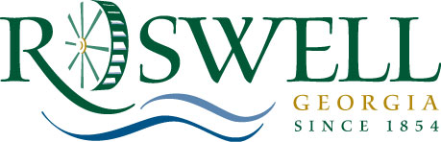

MEMORANDUM

Date: April 27, 2011

To: Community Development and Transportation Committee

From: Alice Wakefield, Community Development Director

Subject: Special Event – City Sponsorship and Rolling Road Closure

The following Special Event has requested City sponsorship and a rolling road closure:

Rock n Ride, organized by Grady Health Foundation, Saturday, June 25, 2011 from 11am to 2pm.

The organizer, Grady Health Foundation, requests City sponsorship for any expenses that may be incurred. The cost for City services is $1656 for police escort from Killer Creek Harley Davidson to GA 400 via Hembree Road / Westside Pkwy / Haynes Bridge Road. See attached for complete route.

